LESSON PLAN FORMAT
SAS Fall 2022
Lead Teacher: Bridget Toren
Unit Title: Maker vs. Viewer
Lesson Title: From Mud to Mugs
Grade Level: 9-12
Number of Students: 5
I. UNIT OVERVIEW (RATIONALE)
Art is made to be experienced. One of the main thoughts of an artist while they are making should be “how is the viewer going to interact with the piece?”. We hope to convey the importance of both the maker and the viewer over this 8 week course and have the students understand the power of sharing their own experiences with the viewers of their work.

II-A. LESSON OVERVIEW (RATIONALE)
In this lesson, students will be thinking about the viewer experiencing their artwork in terms of functionality. They will be making utilitarian cups from white clay that will then be fired and clear glazed. When making the cups, students will need to be thinking about the viewer as a potential buyer. They will be considering each aspect of the design from the lip, handle, foot, and interior of the vessel based on what is most comfortable and aesthetic. The students will learn how to coil, build their mugs and achieve the design they have in mind using various clay tools and handbuilding techniques.

II-B. ESSENTIAL QUESTIONS:
What makes you want to purchase art?
What kind of aesthetics are you drawn to?
How would you design each aspect of a cup to appeal to someone buying it?
How do you hand build a mug?

III-A. LEARNER OBJECTIVES/OUTCOMES
Students will create a mug out of clay using handbuilding techniques.
Students will learn handbuilding techniques and how to use various clay tools.
Students will consider the buyer/user when creating the shape of their mug.
Students will reflect on their piece and others and the functionality of each.

III-B. NATIONAL ART STANDARDS
HS Accomplished VA:Cr1.2.IIa
Choose from a range of materials and methods of traditional and contemporary artistic practices to plan works of art and design.
HS Accomplished VA:Cr3.1.IIa
Engage in constructive critique with peers, then reflect on, re-engage, revise, and refine works of art and design in response to personal artistic vision.

III-C. PENNSYLVANIA DEPARTMENT OF EDUCATION STANDARDS
9.4.12.B. Describe and analyze the effects that works in the arts have on groups, individuals and the culture

IV. ART / ARTIST(S) OF RELEVANCE:
Seong Weon Lee
- Influenced by Korean ceramics
- more focussed on form rather than topical/glaze design
- intentionality in each aspect of the form
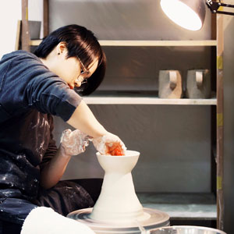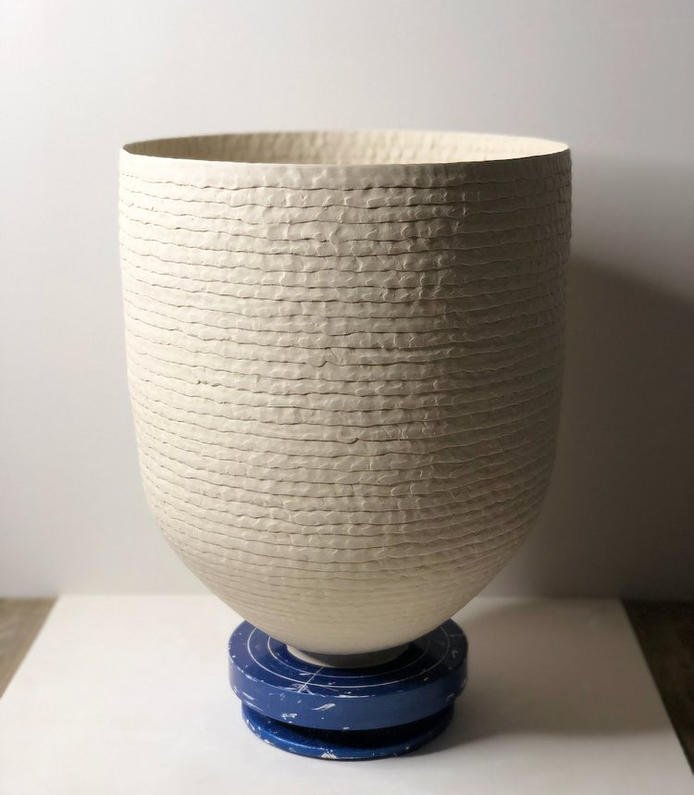
Dara Hartman
- thinks about the subtle interaction people have with the lip of a cup when making
- works in sets
- inspired by Song Dynasty and 18th century Meissen Porcelain
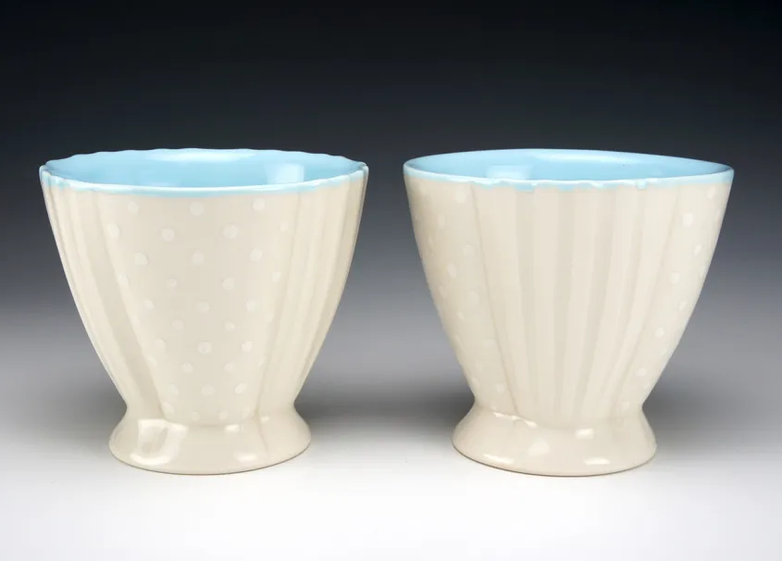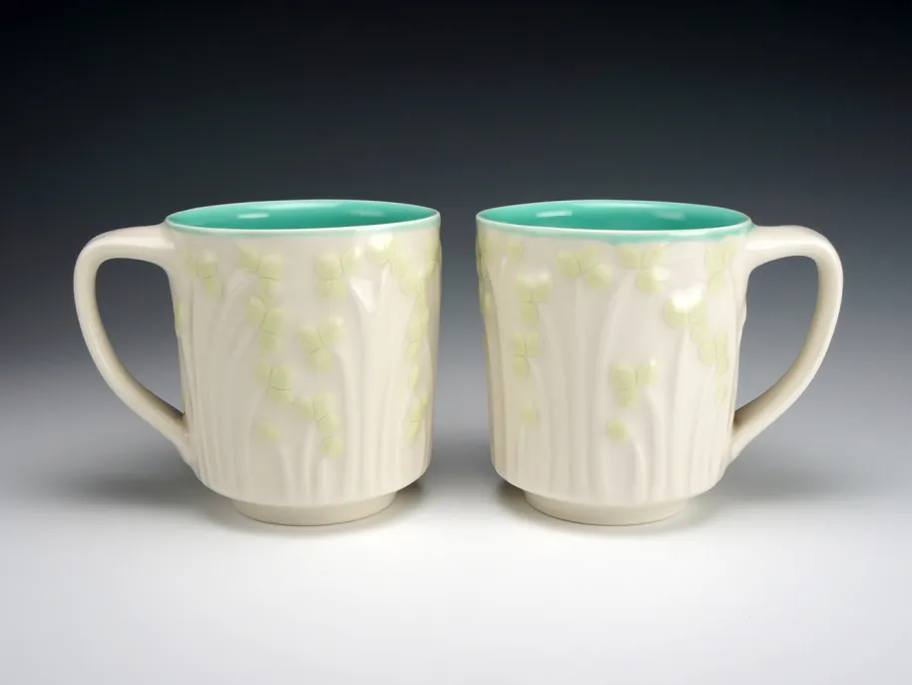
Lisa York
- thinks about the surface design and creating something that will make someone want to pick it up
- inspired by african patterned textiles and natural forms found outdoors
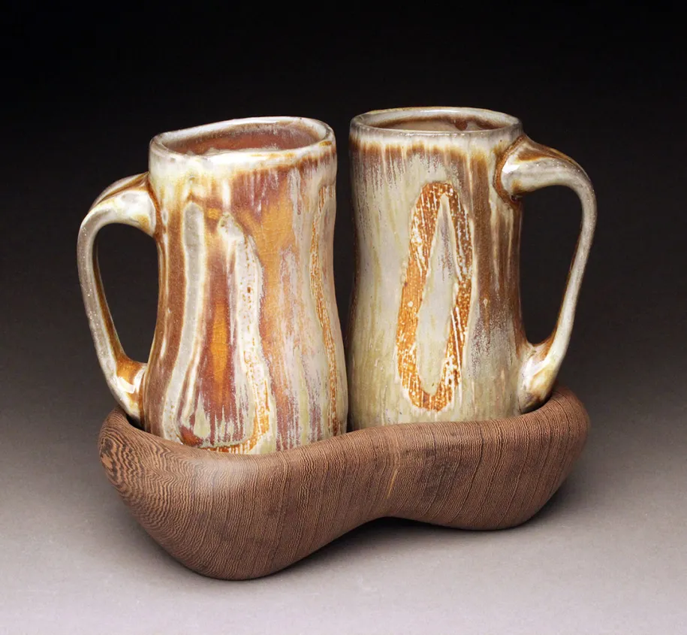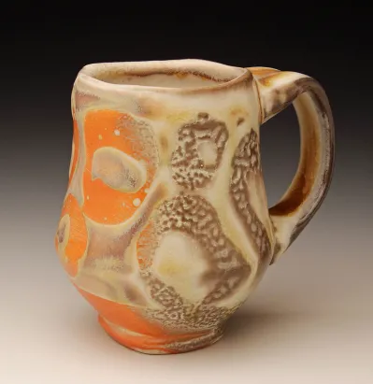
Perry Haas
- wood fired ceramics
- dramatic foot
- different topographical texture to them from the wood firing
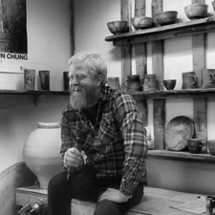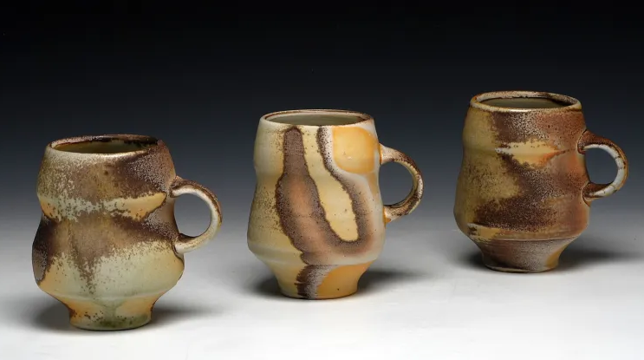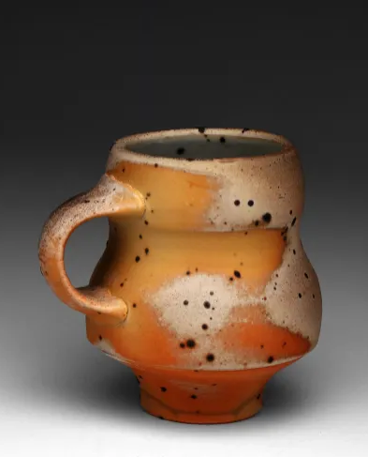

V. PREREQUISITES:
Students should have an understanding of classroom dynamics and should be able to respect and listen to the instructor during direct instruction.

VI. INTERDISCIPLINARY CONNECTIONS:
This lesson will be connected to the science of clay. We will be discussing how clay interacts and how we can manipulate it and interact with it to make something successful. We will be learning about how wedging and coil building affect the clay once it goes through the firing process. We will also be making mugs that are related to our own bodies and how our hands and mouth interact with the mug and will be discussing a little bit of anatomy.

VII. MATERIALS NEEDED FOR LESSON
- clay
- metal and or wooden ribs
- trimming tools
- sponges
- water cups
- brushes
- needle tools
- wire tools
- canvas boards to work on
- teacher examples
- plastic bag

VIII. SAFETY HAZARDS:
Students should be careful when using some of the clay tools that are sharp. They need to understand to always put tools in their containers with the pointed end down, be cautious of themselves and others when they are working with sharp tools and to keep their materials clean.

IX. TEACHER ACTIONS / EXPECTED LEARNER ACTIONS

Time | Teacher Actions | Expected Learner Actions
9:00 - 9:15  15mins | - Welcoming students to the class  - Asking students to begin working on their name tags as other students come in  - Introductions of instructors  - Ice breaker:  - name, pronouns, grade, favorite medium, favorite thing you’ve ever made | - Coming into class, finding a seat and beginning to work on their name tags  - Listening to the instructors as they introduce themselves  - participating in the icebreaker, sharing about themselves, and listening to other classmates as they share
9:15 - 9:25  10 mins | - Listening to instructor so we can assist students later in the day with any questions about the lesson | - Listening to instructors, watching slide presentation, answering questions when prompted, and asking questions if needing more clarification
9:25 - 9:40  15 mins | - Continue listening to instructor so we can assist students later in the day with any questions about techniques | - Watching demonstration of building techniques and tools  - Interacting with mug examples, picking them up and holding them  - seeing what about them appeals to their own style and what functional vs aesthetic choices they want to make in their own work  - Answering questions when prompted and asking questions when needed
9:40 - 10:45  65 mins | - Walking around the room checking in with students as they are working  - Answering any questions that students may have  - Taking pictures and documentation of lead teacher | - Working on their mugs using the coil building techniques and tools demonstrated to them  - Thinking about both the function and aesthetics of the mug as they are working on them  - Asking questions as needed
10:45 - 10:55  10 mins | - Assist Bridget in explaining the clean up process for the tools and tables  - Helping students to label and put away their pieces | - Cleaning up workspace and tools used  - Labeling work and putting it away in designated spaces
10:55 - 11:00  5 mins | - Bridget will give me the opportunity to introduce next week’s lesson and we will all connect the two via the idea of functional vs aesthetics in utilitarian art | - Listening to introduction of next lesson
X. ENDING THE LESSON
X-A. Closure of Lesson:
Since the clay will still be wet, we won’t be able to handle the mugs this day and in one of the other lessons, once they have been fired, we can reflect on each others’ mugs and whether or not we feel they are both functionally and aesthetically strong.

X-B. Transition to Next Lesson:
Bridget and I will briefly introduce my lesson for next week. It is a continuation of consumer and functional art but we will be discussing design through new mediums that include linoleum printing and textiles. Relating to the previous lesson, I will be continuing the idea of “what is consumer art?” through the medium of wearable art. This will relate to the fashion industry and aesthetics within trends and fast fashion.

XI. REFERENCES TO MATERIALS CONSULTED
https://www.swjlceramics.com/two-tone
https://artaxis.org/artist/seong-weon-lee/
https://artaxis.org/artist/lisa-york/
https://artaxis.org/?s=dara+

XII. THE CLASSROOM AS A THIRD TEACHER
The classroom will be set up with large work tables in a cluster for when the students are actually working so that they can be seated near each other for a more collaborative environment. When sharing the slides, we will be seated at the table with them and share the slides from my laptop. This will allow us to be on their level and make the environment more comfortable. I will also have various mug examples on another table in the room so that they can interact with them as desired so that they can get more inspiration on forms to use. For project storage we will take them back over to Patterson and store them in room 308 if possible, or on top of the cabinets in the hallway.

LESSON PLAN FORMAT
SAS Fall 2022
Lead Teacher: Sage Kugler
Unit Title: Maker vs. Viewer
Lesson Title: Printing Our Aesthetics
Grade Level: 9-12
Number of Students: 5

I. UNIT OVERVIEW (RATIONALE)
Art is made to be experienced. One of the main thoughts of an artist while they are making should be “how is the viewer going to interact with the piece?”. We hope to convey the importance of both the maker and the viewer over this 8 week course and have the students understand the power of sharing their own experiences with the viewers of their work.
II-A. LESSON OVERVIEW (RATIONALE)
In this lesson, students will continue to think about the viewer experiencing their art as a buyer of the product. They will be making linoleum stamps to then print onto T-shirts. Students will be considering trends, aesthetics, logos and personal style when designing their prints. They will be learning carving and printing techniques to use on lino boards.

II-B. ESSENTIAL QUESTIONS:
What do you look for in clothing items?
How do trends impact personal style?
What do fashion choices say about an individual?
Where can you see different aesthetics in your everyday life?

III-A. LEARNER OBJECTIVES/OUTCOMES
Students will learn carving and printmaking skills using linoleum boards.
Students will create designs on linoleum inspired by current fashion trends and aesthetics.
Students will explore the idea of consumer and utilitarian art through printmaking on textiles.
Students will reflect on how trends and aesthetics impact the art world and personal style.

III-B. NATIONAL ART STANDARDS
VA:Cr1.2.IIa: Choose from a range of materials and methods of traditional and contemporary artistic practices to plan works of art and design
VA:Cr1.2.Ia: Shape an artistic investigation of an aspect of present day life using a contemporary practice of art or design.
III-C. PENNSYLVANIA DEPARTMENT OF EDUCATION STANDARDS
9.4.12.C: Compare and contrast the attributes of various audiences’ environments as they influence individual aesthetic response.

IV. ART / ARTIST(S) OF RELEVANCE:
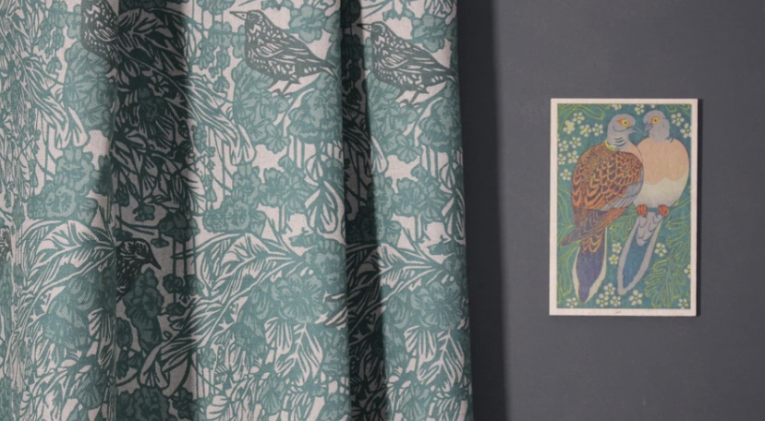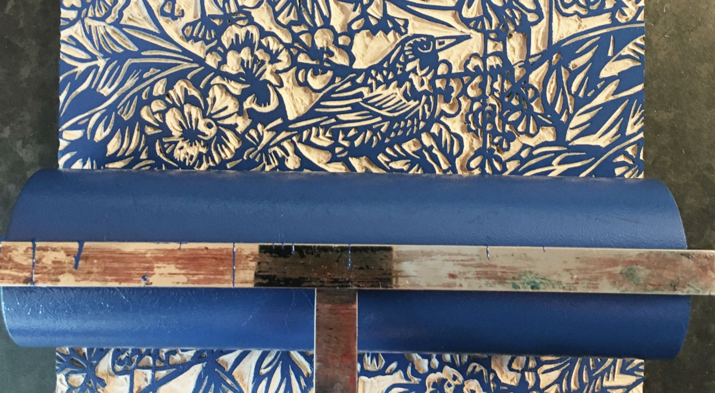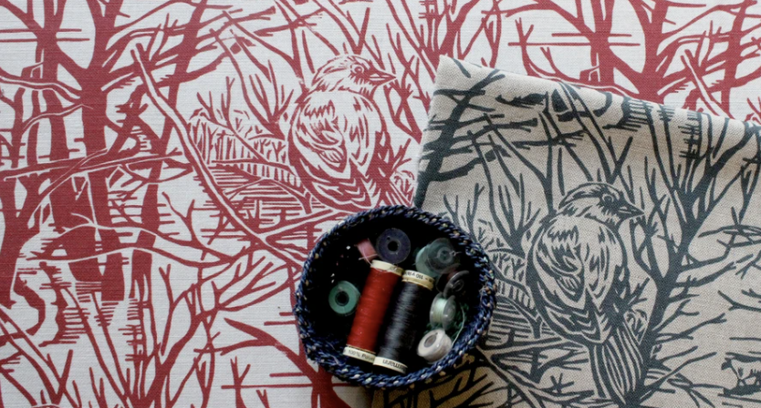
https://susiehetherington.co.uk/
Using her monotone drawings of flowers and the details of nature, Susie soon progressed to block printing – on a steep but exciting learning curve. Printing by hand, and the imperfections it brings, gave Susie's repeat patterns a life and quality she wanted to retain. Her fabric collections, now digitally printed to fabric in the UK, are directly taken from hand drawings and scans of her lino prints, to keep them unique and textural.

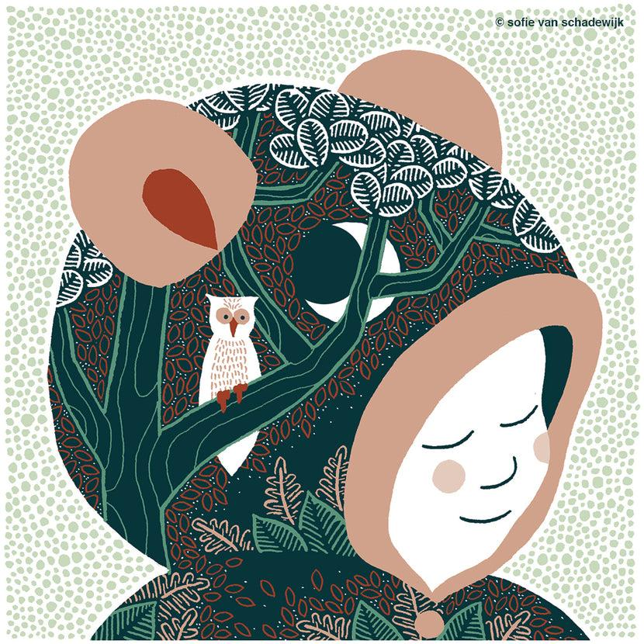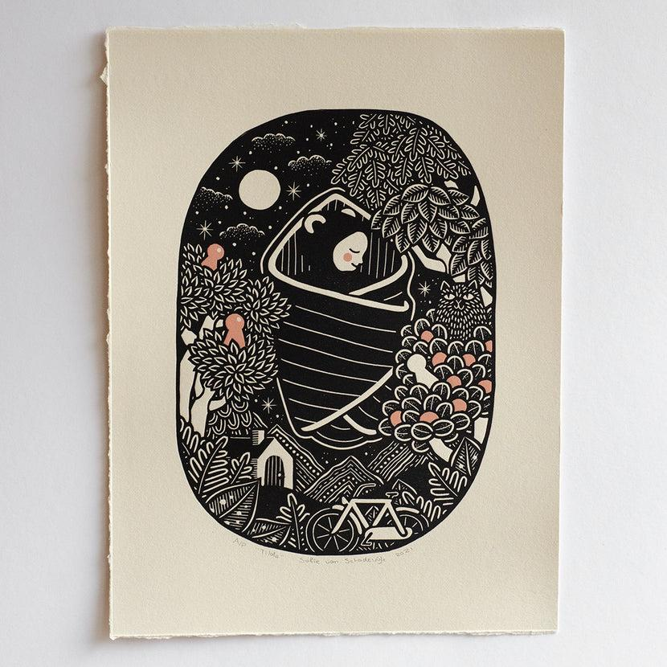
https://sofietekent.nl/pages/about-sofie
My name is Sofie, I'm a printmaker, illustrator, and mom of two little girls. I live in Waalre, which is a small village in the south of the Netherlands (near Eindhoven). The subjects used in my work are women (often in a mindful or meditative state), nature, a little magic (moon, sun, stars, those are kind of magical to me), and there's lots of cats and hair involved as well. I try to create from what I imagine, rather than what I see in front of me.

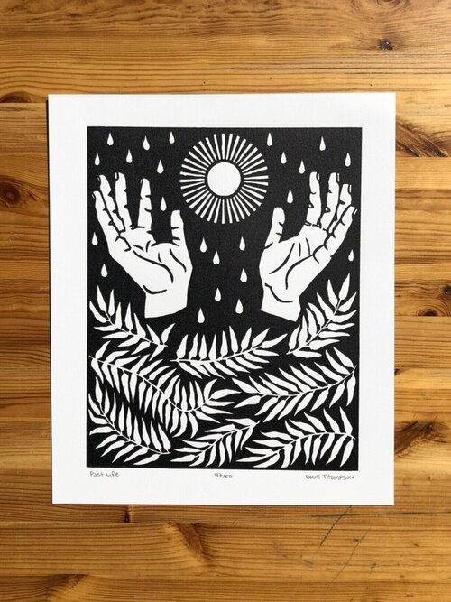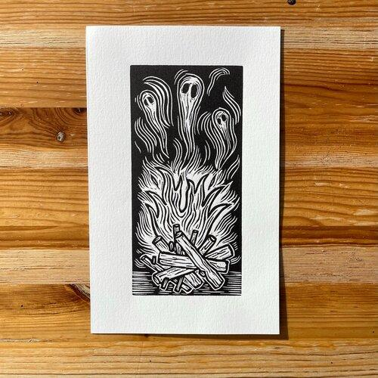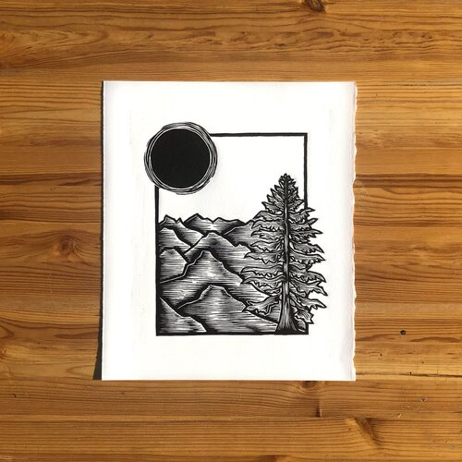
https://www.lakeeffectpnw.com/
Brie Thompson is an artist living in Portland, OR. She is a member of the volunteer-run non-profit printmaking studio, Flight 64 and a member of Speedball’s Professional Artist Network. Her work is influenced by the lush landscape of the Pacific Northwest and her passion for hiking and skiing.

V. PREREQUISITES:
Students should have an understanding of classroom dynamics and should be able to respect and listen to the instructor during direct instruction.

VI. INTERDISCIPLINARY CONNECTIONS:
There will also be a connection with fashion. While it is a creative art form, it’s usually considered to be more a part of “home ec” courses since textiles are a part of sewing, knitting, etc. Students will learn about the consumer side of the fashion industry along with the aesthetic side in terms of how they personally connect to the fashion world through self expression.

VII. MATERIALS NEEDED FOR LESSON

- Linoleum slabs (4x6 inch)
- Carvers (varying sizes)
- Fabric printing ink
- White cotton t-shirts
- Hair dryers
- Brayers
- Paper (mixed media)
- Pencils
- Speedy Carve boards
- Styrofoam

VIII. SAFETY HAZARDS/ACCOMMODATIONS:
Students need to be careful when handling the carvers. They will be taught how to properly cut linoleum to help prevent any injuries. They will be consistently reminded to cut away from their bodies and to keep their fingers away from the blade. It is also important that when the linoleum feels too difficult to cut, they should go to the hair dryers to warm up the material to make it easier to cut. As for accommodations, we will have additional material for students that may find carving linoleum difficult. This will give students a similar experience with a more beginner friendly material. We will also have more consistent check-ins with our students to ensure that those that may need additional help receive it and don’t feel isolated or excluded from the rest of the class.

IX. TEACHER ACTIONS / EXPECTED LEARNER ACTIONS

Time | Teacher Actions | Expected Learner Actions
9:00 - 9:05  5 mins | - Welcoming students to the class  - Have students come in, grab their name tags, and get settled before the lesson | - Coming to class, finding a seat, and getting settled before class begins
9:05 - 9:15  10 mins | - Introducing lesson using slides  - https://docs.google.com/presentation/d/1M8kRuSwct_Jh9iV-J9O48ccCjifCIZLYrFkX8ty1S9U/edit?usp=sharing  - explaining concept of unit and how this lesson fits into it  - sharing artists of relevance  - introducing what we will be doing for this lesson | - Listening to instructors, watching slide presentation, answering questions when prompted, and asking questions if needing more clarification
9:15 - 9:25  10 mins | - Demonstration on how to carve linoleum boards  - Showing different techniques to make sure carving is simple and safe (using hairdryers, carving away from body)  - Showing students how deep to carve  - They can always carve more after printing if marks aren’t showing up how they want them to  - They will see my carving and how different patterns/images/etc play into consumer trends | - Watching demonstration of carving techniques and tools  - Interacting with lino example  - seeing what about them appeals to their own style and what functional vs aesthetic choices they want to make in their own work  - Answering questions when prompted and asking questions when needed
9:25 - 10:00  35 mins | - Walking around the room checking in with students as they are working  - Answering any questions that students may have | - Working on their lino board designs and carving techniques  - Thinking about patterns and images that relate to consumer aesthetics  - Asking questions as needed
10:00 - 10:10  10 mins | - Demonstration on printing their lino boards  - Showing techniques on how much ink to use, how to use brayers and how to ensure that the lino board prints evenly  - Demonstrating on paper before the T-shirt so students can see if there are areas that need to be carved more within their sketchbooks  - Then, once the linoboard is ready and they feel confident in their prints on paper, they can print on their T-shirts | - Watch demonstration of printing the lino boards  - Answering questions when prompted and asking questions when needed
10:10 - 10:45  35 mins | - Walking around the room checking in with students as they are working  - Answering any questions that students may have | - Working on their lino boards and finishing any last carvings or further carving after test prints  - Begin practice prints on paper to make sure they understand how to print properly and to make sure the linocuts are printed as desired  - Begin printing on T-shirts after practice prints when they feel confident  - Asking questions as needed
10:45 - 10:55  10 mins | - Explaining the clean up process for the tools and tables  - Helping students to label and put away their t-shirts | - Cleaning up workspace and tools used  - Labeling work and putting it away in designated spaces
10:55 - 11:00  5 mins | - I will be introducing next week’s lesson which will lead into the new topic of how artists and viewers use and experience the physical space of an artwork using silhouettes and shadows. | - Listening to introduction of next lesson

X. ENDING THE LESSON

X-A. Closure of Lesson:
Students will use this time to reflect on one another’s lino prints and how that relates to the consumer world and the fashion industry. We will hold onto the t-shirts since they will need some time to cure and dry before they can be worn.

X-B. Transition to Next Lesson:
We will be officially moving on from looking at art as consumer and for utilitarian purposes and now we will be exploring the relationship between the viewer and the physical space. I will be focusing on silhouettes and shadows so they will be thinking about how shapes impact the physical experience.

XI. REFERENCES TO MATERIALS CONSULTED
https://susiehetherington.co.uk/
https://sofietekent.nl/pages/about-sofie
https://www.lakeeffectpnw.com/

XII. THE CLASSROOM AS A THIRD TEACHER
The classroom will be set up with large work tables in a cluster for when the students are actually working so that they can be seated near each other for a more collaborative environment. As for printmaking, they will have one cluster of tables to use as a clean carving station, while the other cluster will be used as the printing station. When sharing the slides, we will be seated at the table with them and share the slides from my laptop. This will allow us to be on their level and make the environment more comfortable.
LESSON PLAN FORMAT
SAS Fall 2022
Lead Teacher: Sage Kugler
Unit Title: Maker vs. Viewer
Lesson Title: Altering Light and Shadows
Grade Level: 9-12
Number of Students: 5

I. UNIT OVERVIEW (RATIONALE)
Art is made to be experienced. One of the main thoughts of an artist while they are making should be “how is the viewer going to interact with the piece?”. We hope to convey the importance of both the maker and the viewer over this 8 week course and have the students understand the power of sharing their own experiences with the viewers of their work.
II-A. LESSON OVERVIEW (RATIONALE)
As we transition out of consumer and utilitarian art, the next area within the artworld that we experience is installation art. Students will be creating their own installation art using light and shadows to create silhouette art. They will be considering as the maker the physical space and their senses to understand how their installation work translates into the environment the viewer will experience it.

II-B. ESSENTIAL QUESTIONS:
How might light impact the physical space of an art installation?
What are some important aspects to a successful installation?
What are some examples of installation art that you experienced?

III-A. LEARNER OBJECTIVES/OUTCOMES
Students will create installation art using light and silhouettes.
Students will experiment with light and shadow to create silhouette art.
Students will use their physical space to create art that interacts with the environment using light and shadows.

III-B. NATIONAL ART STANDARDS
VA:Cr2.1.IIIa: Experiment, plan, and make multiple works of art and design that explore a personally meaningful theme, idea, or concept.
VA:Cr2.2.IIIa: Demonstrate understanding of the importance of balancing freedom and responsibility in the use of images, materials, tools, and equipment in the creation and circulation of creative work.
III-C. PENNSYLVANIA DEPARTMENT OF EDUCATION STANDARDS
9.1.12.E: Delineate a unifying theme through the production of a work of art that reflects skills in media processes and techniques.
IV. ART / ARTIST(S) OF RELEVANCE:

Kara Walker
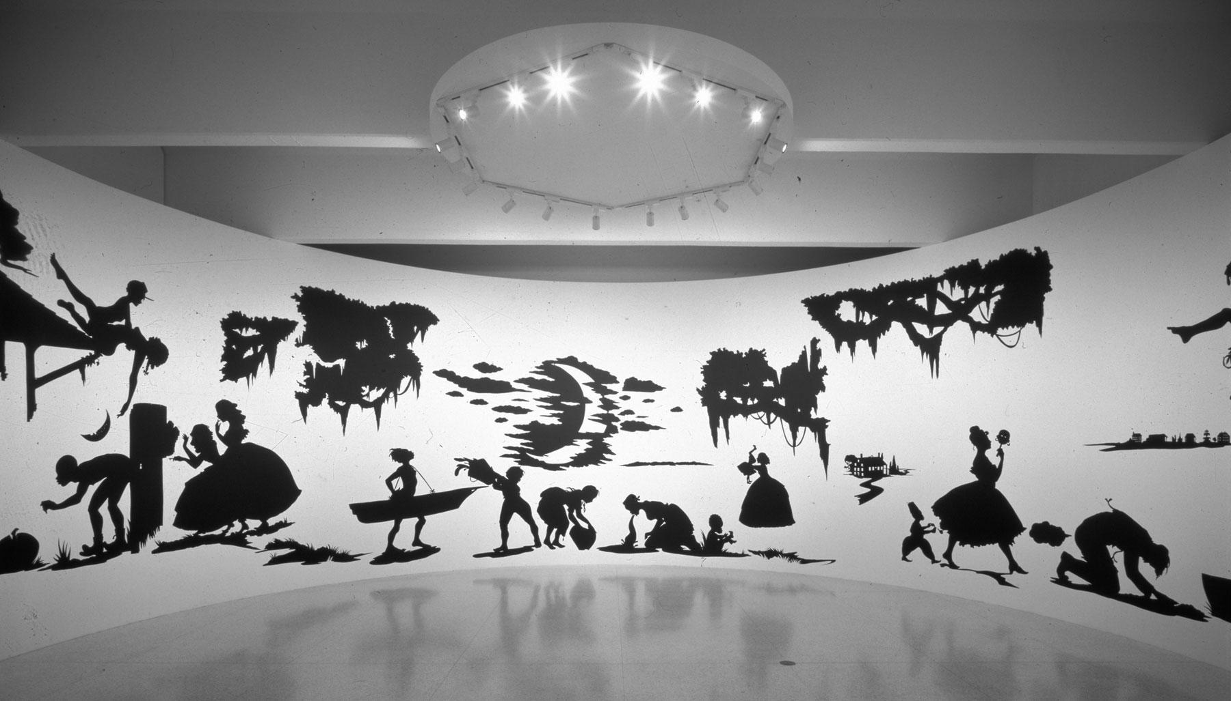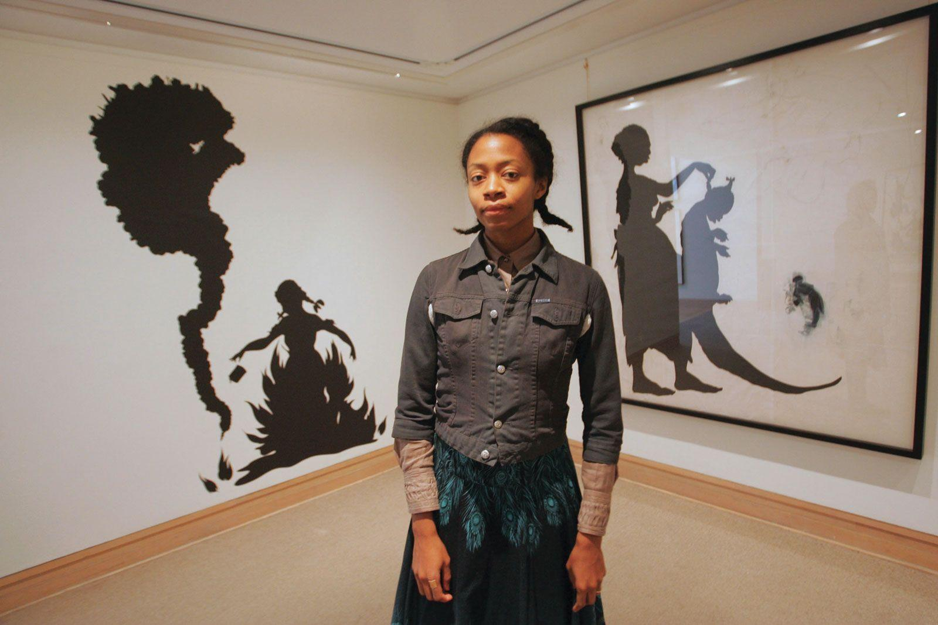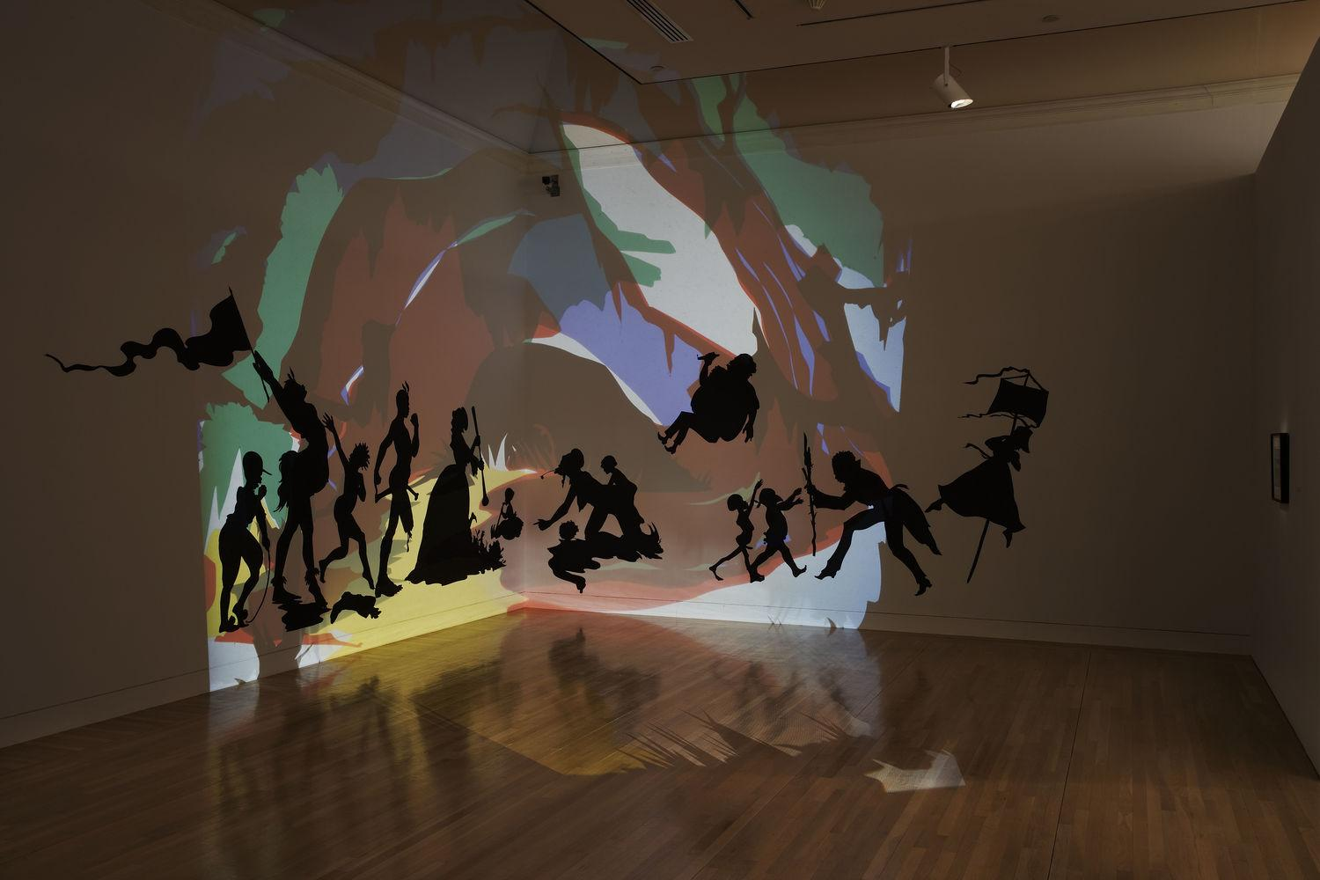
New York-based artist Kara Walker is best known for her candid investigation of race, gender, sexuality, and violence through silhouetted figures that have appeared in numerous exhibitions worldwide.

V. PREREQUISITES:
Students should have an understanding of classroom dynamics and should be able to respect and listen to the instructor during direct instruction.
Students should have an understanding of light and shadows and how they interact with one another.

VI. INTERDISCIPLINARY CONNECTIONS:
Installation art is a very broad area within the artworld. In this lesson, students will be tapping into their visual physical senses to create installation artwork using shadow and light to create silhouettes. These can be connected to their science courses in terms of how light and shadow impact their physical environment and how that can create new shapes and ideas.

VII. MATERIALS NEEDED FOR LESSON

- Lights
- Large Black Paper
- X-Acto Knives
- Scissors
- Pencils

VIII. SAFETY HAZARDS AND ACCOMODATIONS:
Students need to be careful when handling the x-acto knives. They will be taught how to properly cut paper with the x-acto knives to help prevent any injuries. They will be consistently reminded to cut away from their bodies and to keep their fingers away from the blade. As for accommodations, we will have more consistent check-ins with our students to ensure that those that may need additional help receive it and don’t feel isolated or excluded from the rest of the class.

IX. TEACHER ACTIONS / EXPECTED LEARNER ACTIONS

Time | Teacher Actions | Expected Learner Actions
9:00 - 9:15  15 mins | - Welcoming students to the class  - Have students come in, grab their name tags, sketchbooks and/or printmaking materials and get settled before the lesson | - Coming to class, finding a seat, and getting settled before class begins  - If students did not finish their prints from the previous class, they will have time to complete their carvings and prints on T-shirts  - If students did complete their prints, they can use this time to free draw in their sketchbooks
9:15 - 9:25  10 mins | - Introducing lesson using slides  - https://docs.google.com/presentation/d/1x-h9Bouas-ukxnM-a_XFl52CNZtIVrozp_2uxMS1an8/edit?usp=sharing  - explaining concept of unit and how this lesson fits into it  - sharing artists of relevance  - introducing what we will be doing for this lesson | - Listening to instructors, watching slide presentation, answering questions when prompted, and asking questions if needing more clarification
9:25 - 9:35  10 mins | - Demonstrating how to safely use x-acto knives when cutting the shapes they need  - Explaining how much paper to start with and we can always cut more for them to use  - Students will have access to light sources so we will display them in an area where they can experiment and manipulate them with their artworks | - Watching demonstration of x-acto techniques and tools  - Interacting with silhouette example  - seeing what about them appeals to their own style and how light and shadow can change the artwork  - Answering questions when prompted and asking questions when needed
9:35 - 10:45  70 mins | - Walking around the room checking in with students as they are working  - Answering any questions that students may have | - Working on their silhouette pieces  - Cutting and gluing their pieces together  - Experimenting with light sources  - Asking questions as needed
10:45 - 10:55  10 mins | - Explaining the clean up process for the tools and tables  - Helping students to label and put away their artworks | - Cleaning up workspace and tools used  - Labeling work and putting it away in designated spaces
10:55 - 11:00  5 mins | - We will be introducing next week’s lesson which will continue the topic of installation art and how the viewer interacts and experiences it using soundscapes | - Listening to introduction of next lesson

X. ENDING THE LESSON

X-A. Closure of Lesson:
Students will use this time to reflect on their silhouettes and map out how they want their artworks to be displayed for the final exhibition. We will hold onto their pieces in the meantime as we discuss our final thoughts surrounding light and shadow’s impact on installation art.

X-B. Transition to Next Lesson:
Bridget, Katy and I will briefly introduce our lesson for next week. It is a continuation of installation art but we will be discussing soundscapes and how they convey auditory experiences into visual representations. Relating to the previous lesson, students will be creating installation artworks by recording sounds from their environments and transcribing them into two dimensional paintings using color theory and mark making to convey their visual and emotional experiences.
XI. REFERENCES TO MATERIALS CONSULTED
http://www.karawalkerstudio.com/

XII. THE CLASSROOM AS A THIRD TEACHER
The classroom will be set up with large work tables in a cluster for when the students are actually working so that they can be seated near each other for a more collaborative environment. As for creating their installation art, they will have the same set up as previous classes with two main clusters of tables to cut out their silhouettes, but there will be more open space within the classroom for students to explore how their silhouettes can coexist with light sources. When sharing the slides, we will be seated at the table with them and share the slides from my laptop. This will allow us to be on their level and make the environment more comfortable.

LESSON PLAN FORMAT
SAS Fall 2022
Lead Teacher: Sage Kugler, Bridget Toren, Katy Ulmer
Unit Title: Maker vs. Viewer
Lesson Title: Altering Light and Shadows Cont.
Grade Level: 9-12
Number of Students: 5
I. UNIT OVERVIEW (RATIONALE)
Art is made to be experienced. One of the main thoughts of an artist while they are making should be “how is the viewer going to interact with the piece?”. We hope to convey the importance of both the maker and the viewer over this 8 week course and have the students understand the power of sharing their own experiences with the viewers of their work.
II-A. LESSON OVERVIEW (RATIONALE)
This week will be a time for students to finish up their carving projects and also collaboratively work on the silhouette scene that was started last week. Students will be creating their own installation art using light and shadows to create silhouette art. They will be considering as the maker the physical space and their senses to understand how their installation work translates into the environment the viewer will experience it. If students finish early, they will be experimenting with sound scapes and how to depict a non-visual thing in a visual artwork.

II-B. ESSENTIAL QUESTIONS:
-What makes a successful installation?
-How does the dynamic between light and shadow impact the physical space of an art installation?
-How does the large scale of installation work like Kara Walker’s change the relationship between the viewer and the artwork? Students consider other questions like:
-Should the figures be life sized?
-How would projecting the viewer's silhouette onto the wall affect the piece?
-Does the lack of dimension and detail in the silhouettes change how you approach the
composition?

III-A. LEARNER OBJECTIVES/OUTCOMES
Students will create installation art using light and silhouettes.
Students will use their physical space to create art that interacts with the environment using light and shadows.

III-B. NATIONAL ART STANDARDS
VA:Cr2.1.IIIa: Experiment, plan, and make multiple works of art and design that explore a personally meaningful theme, idea, or concept.
VA:Cr2.3.Ia: Collaboratively develop a proposal for an installation, artwork, or space design that transforms the perception and experience of a particular place.
III-C. PENNSYLVANIA DEPARTMENT OF EDUCATION STANDARDS
9.1.12.E: Delineate a unifying theme through the production of a work of art that reflects skills in media processes and techniques.

IV. ART / ARTIST(S) OF RELEVANCE:
Melissa McCracken
- has synesthesia which means she can see color when she hears music
- paints what she sees when she listens to her favorite songs
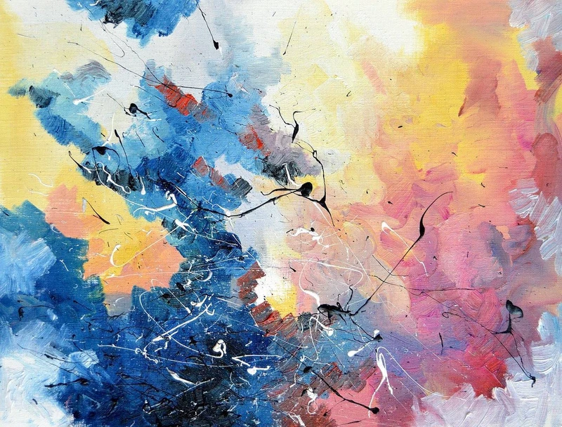Life on Mars - David Bowie
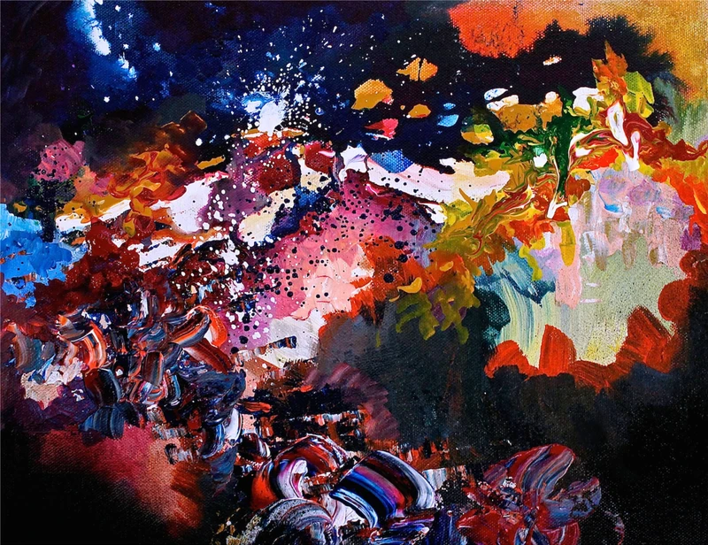Karma Police - Radiohead
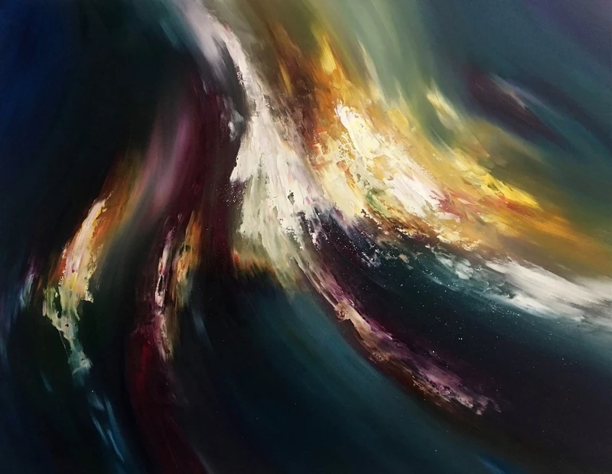Bach - Cello Suite No. 1

Kara Walker
- investigates race, gender, sexuality and violence in her silhouette pieces
- storytelling that involves the viewer, projects a light onto the work so that as the viewer approaches the piece their own shadow is cast on it and they interact with the work

V. PREREQUISITES:
Students should have an understanding of classroom dynamics and should be able to respect and listen to the instructor during direct instruction.
Students should have an understanding of light and shadows and how they interact with one another.

VI. INTERDISCIPLINARY CONNECTIONS:
Installation art is a very broad area within the artworld. In this lesson, students will be tapping into their visual physical senses to create installation artwork using shadow and light to create silhouettes. These can be connected to their science courses in terms of how light and shadow impact their physical environment and how that can create new shapes and ideas. This lesson also brings in elements from English where they will be using storytelling to generate ideas for their installation.

VII. MATERIALS NEEDED FOR LESSON
- Lights
- Large Black Paper
- X-Acto Knives
- Scissors
- Pencil
- Brayers
- Carvers (varying sizes)
- Fabric printing ink
- White cotton t-shirts
- Paper (mixed media)
- Speedy Carve boards
- Styrofoam

VIII. SAFETY HAZARDS AND ACCOMMODATIONS:
Students need to be careful when handling the x-acto knives. They will be reminded how to properly cut paper with the x-acto knives to help prevent any injuries, ie: they should cut away from their bodies and to keep their fingers away from the blade. As for accommodations, we will have more consistent check-ins with our students to ensure that those that may need additional help receive it and don’t feel isolated or excluded from the rest of the class.
IX. TEACHER ACTIONS / EXPECTED LEARNER ACTIONS

Time | Teacher Actions | Expected Learner Actions
9:00 - 9:15  15 mins | - Welcoming students to the class  - Have students come in, grab their name tags, sketchbooks and/or printmaking materials and get settled before the lesson | - Coming to class, finding a seat, and getting settled before class begins  - If students did not finish their prints from the previous class, they will have time to complete their carvings and prints on T-shirts  - If students did complete their prints, they can use this time to free draw in their sketchbooks
9:15 - 9:25  10 mins | - For students that were NOT here last lesson  - https://docs.google.com/presentation/d/1x-h9Bouas-ukxnM-a_XFl52CNZtIVrozp_2uxMS1an8/edit?usp=sharing  - Catch students up on what they missed and discuss silhouette and installation art  - For students that were here  - Continue working on their printing project or silhouette art | - listening to presentation of slides and material missed last week  - asking questions if needed
9:25 - 10:45  80 mins | - Walking around the room checking in with students as they are working  - Answering any questions that students may have  *If students finish early*  - Introduce soundscapes lesson and give them handout (see below) with the lesson overview and artist examples  - Provide materials for the lesson (painting supplies, paint, mixed media paper, etc)  - Spotify Playlist: https://open.spotify.com/playlist/6fv1ru4fzy0hEMreM6cc18?si=aa173447f31f4383 | - Working on their silhouette pieces or printing  - Asking questions as needed  *If students finish early*  - Read the handout and begin working on the lesson
10:45 - 10:55  10 mins | - Explaining the clean up process for the tools and tables  - Helping students to label and put away their artworks | - Cleaning up workspace and tools used  - Labeling work and putting it away in designated spaces
10:55 - 11:00  5 mins | - Bridget will be introducing next week’s lesson which will continue the topic of installation art and how the viewer interacts physically with the piece. The students will be making a class quilt out of various textiles | - Listening to introduction of next lesson

X. ENDING THE LESSON

X-A. Closure of Lesson:
Students will use this time to reflect on their silhouettes and map out how they want their artworks to be displayed for the final exhibition. We will hold onto their pieces in the meantime as we discuss our final thoughts surrounding light and shadow’s impact on installation art.

X-B. Transition to Next Lesson:
Next week, we will be continuing to explore the idea of maker vs. viewer by creating another collaborative piece. Students will be creating their own square of textiles that will then all be joined together in a class quilt. We will be carrying over the themes of viewer interaction that we have discussed in this lesson but now shifting it from the sense of sight to that of touch.
XI. REFERENCES TO MATERIALS CONSULTED
http://www.karawalkerstudio.com/
https://www.vice.com/en/article/gyxq73/melissa-mccracken-synesthesia-painter-interview

XII. THE CLASSROOM AS A THIRD TEACHER
The classroom will be set up with large work tables in a cluster for when the students are actually working so that they can be seated near each other for a more collaborative environment. As for creating their installation art, they will have the same set up as previous classes with two main clusters of tables to cut out their silhouettes, but there will be more open space within the classroom for students to explore how their silhouettes can coexist with light sources. When sharing the slides, we will be seated at the table with them and share the slides from my laptop. This will allow us to be on their level and make the environment more comfortable.

Soundscape Mini-Lesson Handout:
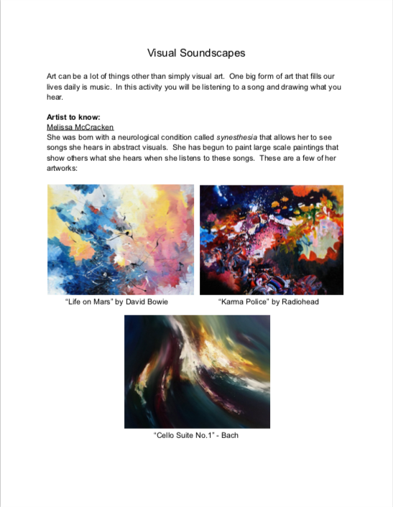
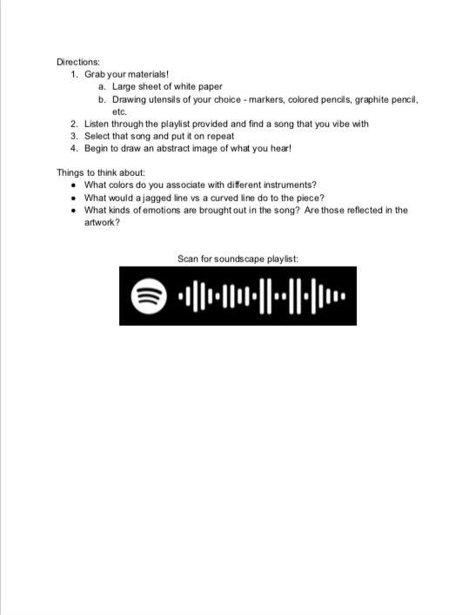
LESSON PLAN WEEK 5
SAS Fall 2022
Lead Teacher: Bridget Toren
Unit Title: Maker vs. Viewer
Lesson Title: Tex“tiles”
Grade Level: 9-12
Number of Students: 5

I. UNIT OVERVIEW (RATIONALE)
Art is made to be experienced. One of the main thoughts of an artist while they are making should be “how is the viewer going to interact with the piece?”. We hope to convey the importance of both the maker and the viewer over this 8 week course and have the students understand the power of sharing their own experiences with the viewers of their work.

II-A. LESSON OVERVIEW (RATIONALE)
In this lesson, students will be thinking about how the viewer will be physically interacting with their piece. They will each create a textile square that incorporates various textures, colors, and materials that will be both visually interesting for the viewer and appealing to touch. Students will be using weaving, sewing, felting, and other methods of working with textiles. Then, each of the student’s squares will be attached together into a class quilt that will be hung for visitors to interact with in the final gallery show.

II-B. ESSENTIAL QUESTIONS:
What textures feel good? What feels bad? Why?
How can you attach different pieces of fabric or textile materials together?
How do you weave, sew, knot, and felt?

III-A. LEARNER OBJECTIVES/OUTCOMES
Students will create a square of various fabrics and textiles.
Students will learn weaving, felting, and sewing techniques.
Students will consider the viewer physically interacting with their piece as well as looking at it.
Students will collaborate with peers.

III-B. NATIONAL ART STANDARDS
VA:Cr1.1.Ia
Use multiple approaches to begin creative endeavors.
VA:Cr1.2.IIa
Choose from a range of materials and methods of traditional and contemporary artistic
practices to plan works of art and design.
VA:Pr5.1.Ia
Analyze and evaluate the reasons and ways an exhibition is presented.

III-C. PENNSYLVANIA DEPARTMENT OF EDUCATION STANDARDS
9.4.12.C. Compare and contrast the attributes of various audiences' environments as they influence individual aesthetic response

IV. ART / ARTIST(S) OF RELEVANCE:
Sarah Zapata
- Yarn, synthetic fabric, wood, large scale installations
- traditional crafts used by women in a monumental, abstract manner, to be a tactile embodiment of gender and cultural performativity
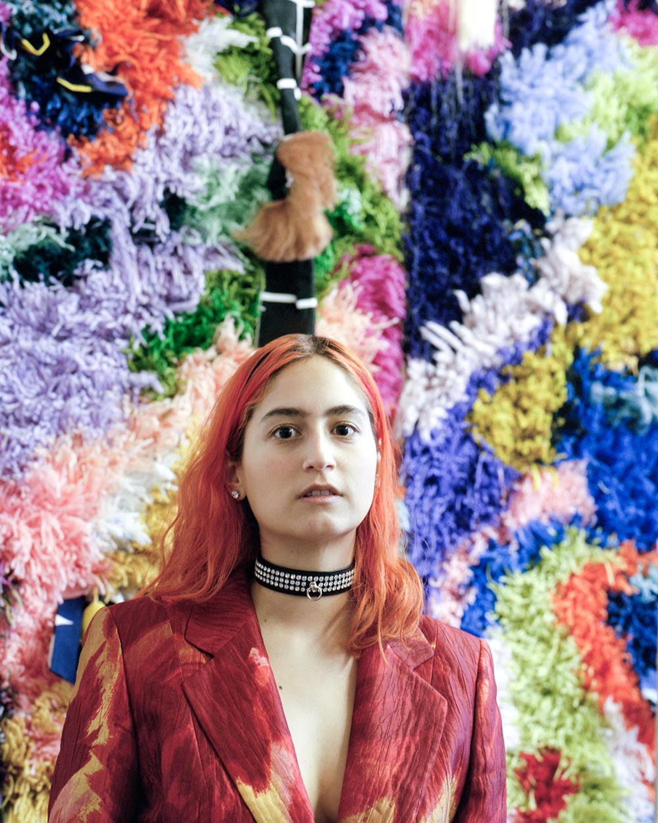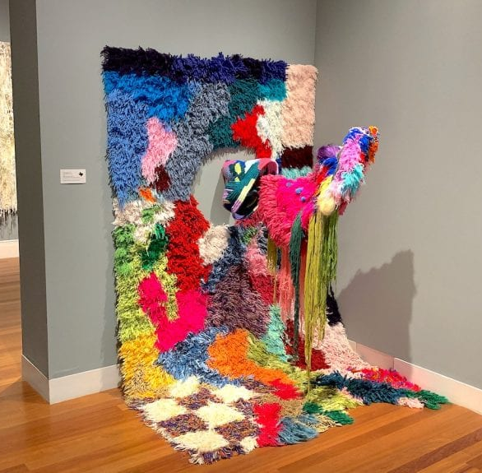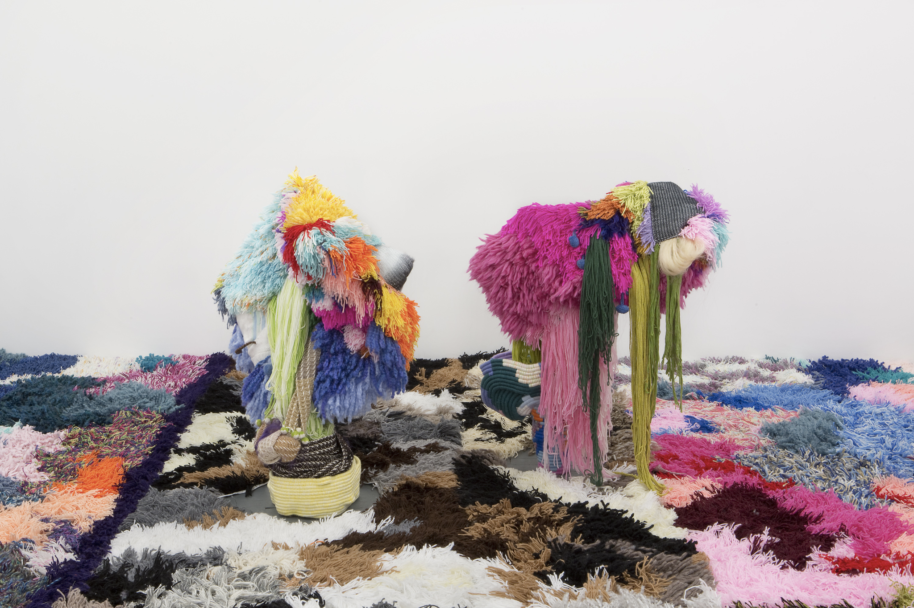

Tessa Perlow
- embroidery and beading
- layered patterns to create visual and textural interest
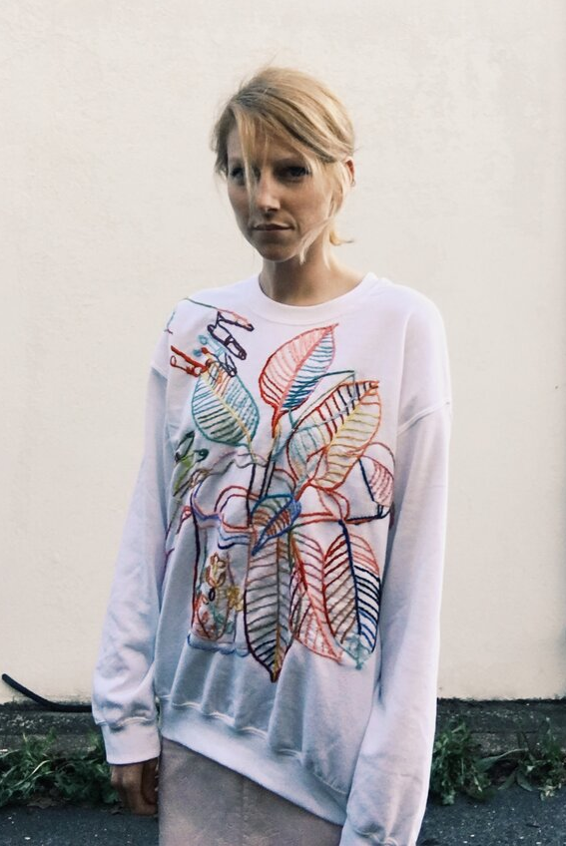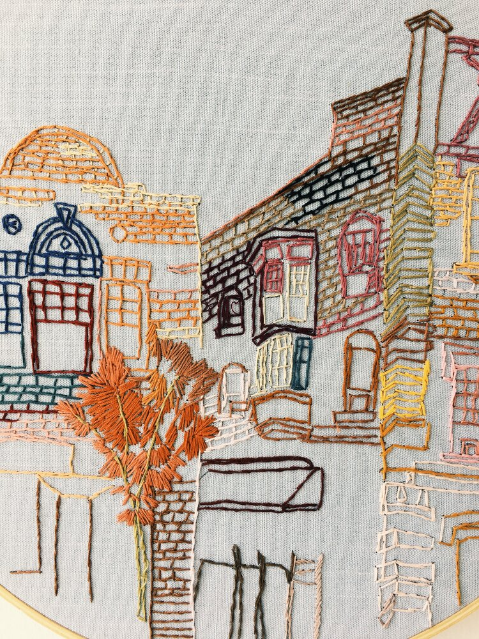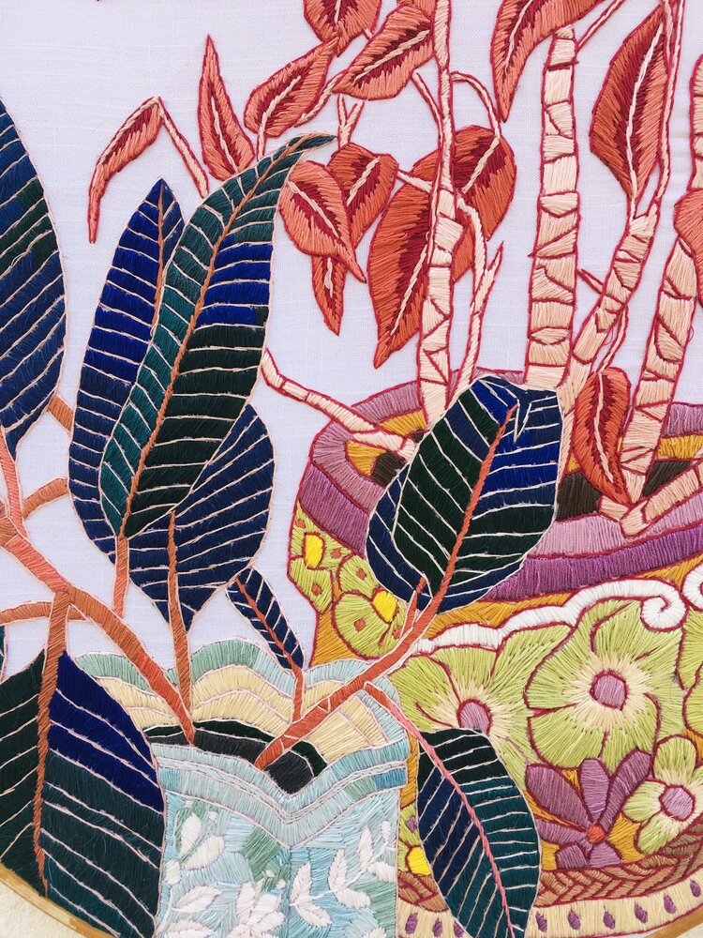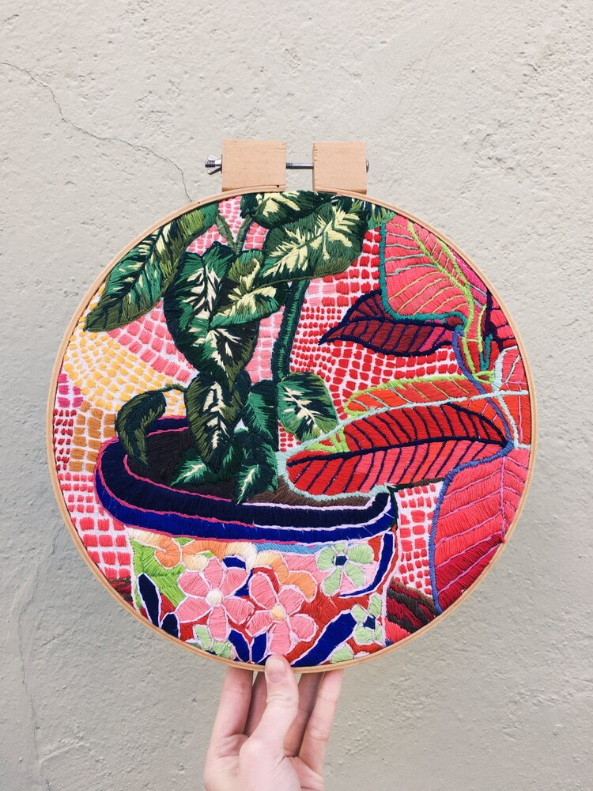

Andrea Graham
- felt artist
- organic shapes inspired by natural motifs
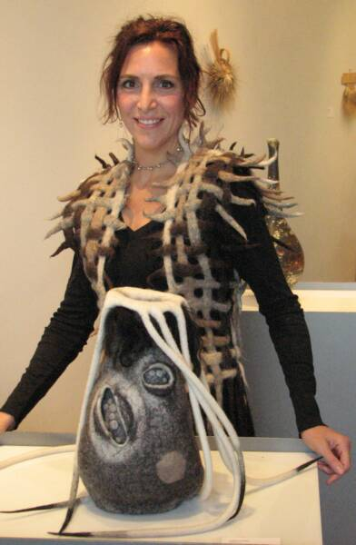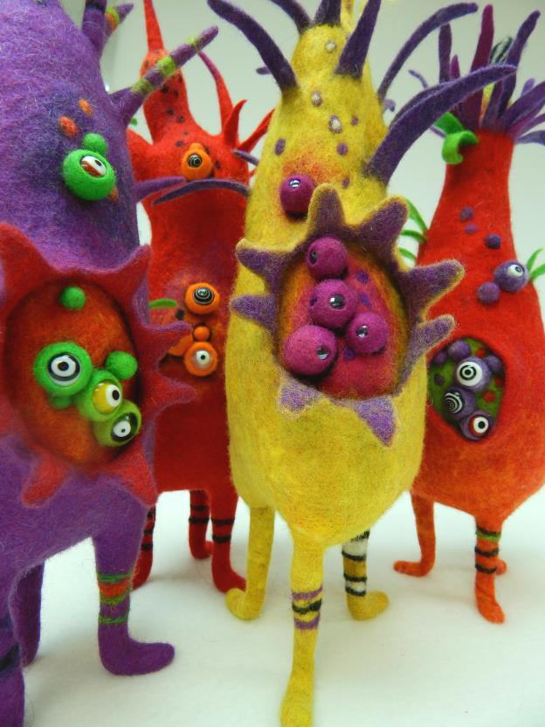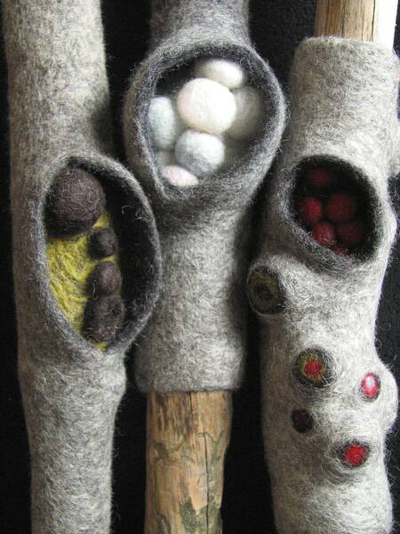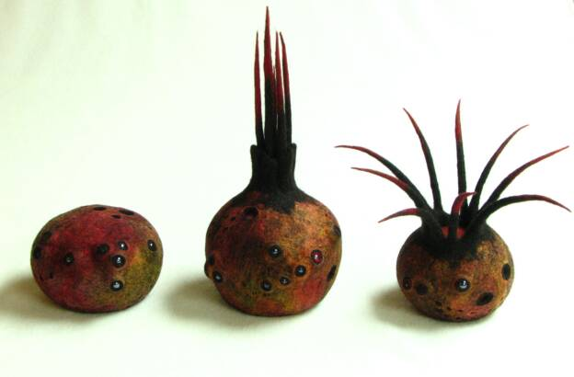

V. PREREQUISITES:
Students should have an understanding of our unit theme and be prepared to think about the viewer interacting with their piece when creating their work. If they have had experience sewing or working with fabrics it will help but we will be doing a brief demo so it is not necessary.

VI. INTERDISCIPLINARY CONNECTIONS:
This lesson will help teach the students problem solving skills. They will be given a wide variety of materials and techniques of how to work with textiles. These skills are things they can use outside of the classroom to mend things and fix everyday problems.

VII. MATERIALS NEEDED FOR LESSON
- needle
- thread
- fabric scraps
- canvas squares
- felt
- ribbon
- yarn
- fabric or tacky glue
- sequins

VIII. SAFETY HAZARDS:
Students will be debriefed on how to safely use a needle and thread and also a needle for felting. The students will have the option of using a plastic needle instead. We will also have fabric glue if students would prefer to use that.

IX. TEACHER ACTIONS / EXPECTED LEARNER ACTIONS

Time | Teacher Actions | Expected Learner Actions
9:00 - 9:15  15 mins | - Welcoming students to class and checking them in  - Asking students to start sketching patterns and designs in their sketchbook and to begin a list of textures that are appealing and unappealing to them | - Coming into class and checking in  - Sketching designs and patterns in sketchbook and coming up with list of textures
9:15 - 9:25  10 mins | - Listen to instructor introducing lesson using slides  - explaining what we would be doing today  - asking discussion questions  - sharing lists of textures  - Listening to instructor so we can assist students later in the day with any questions about the lesson | - Listening to instructors, watching slide presentation, answering questions when prompted, and asking questions if needing more clarification
9:25 - 9:40  15 mins | - Continue listening to demonstration of fabric techniques  - different stitches  - felting  - weaving  - knotting  - glue  - Go over safety information when working with the needles | - Watching demonstration of fabric techniques  - Listening to safety information  - Answering questions when prompted and asking questions when needed
9:40 - 10:50  70 mins | - Walking around the room checking in with students as they are working  - Answering any questions that students may have | - Working on their squares using the fabric techniques demonstrated to them  - Thinking about making their square visual interesting and also appealing to touch as they are working on them  - Asking questions as needed
10:50 - 10:55  5 mins | - Assist instructor on explaining the clean up process for the tools and tables  - Helping students to label and put away their pieces | - Cleaning up workspace and tools used  - Labeling work and putting it away in designated spaces
10:55 - 11:00  5 mins | - Introducing next week’s lesson and connecting the two via the idea of interactive artwork and working with fabric | - Listening to introduction of next lesson
X. ENDING THE LESSON
X-A. Closure of Lesson:
At the end of the lesson we will lay out all of the squares and decide what order we want them to be in for the whole class piece. They will then be attached together and ready to hang in the final show.

X-B. Transition to Next Lesson:
In the next lesson, Katy will be beginning an installation piece with the students where they will be working with fabric and the idea of physically interacting with artwork which will carry over from this lesson. She will give them a brief introduction of next week’s lesson at the end of the class.

XI. REFERENCES TO MATERIALS CONSULTED
https://www.tessaperlow.com/archive
http://www.andrea-graham.com/
https://www.sarah-zapata.com/

XII. THE CLASSROOM AS A THIRD TEACHER
The classroom will be set up with one large table for all the students to work around like it has been for the last few weeks. This will help to continue the consistency with the students and give them the routine of knowing where to go and work as they come into class. Then we will have tables set up along the one side of the room with all the various fabrics, ribbons, felt, etc. for the students to come over to and grab as they see fit. This buffet-style set up I think will make it a little bit more fun for the students and allow for more movement throughout the class period.

LESSON PLAN FORMAT
SAS Fall 2022
Lead Teacher: Katy Ulmer
Unit Title: Maker vs. Viewer
Lesson Title: Immersive Sculpture
Grade Level: 9-12
Number of Students: 5

I. UNIT OVERVIEW (RATIONALE)
Art is made to be experienced. One of the main thoughts of an artist while they are making should be “how is the viewer going to interact with the piece?”. We hope to convey the importance of both the maker and the viewer over this 8 week course and have the students understand the power of sharing their own experiences with the viewers of their work.
II-A. LESSON OVERVIEW (RATIONALE)

In this lesson students will be approaching the viewer as the experiencer of their art. In past lessons we’ve explored different perspectives on viewer-artwork interaction such as viewer as user (mugs), viewer as participant (silhouettes), and viewers as physical interactor (textile squares). This lesson will employ examples of experiential art such as the full room installations of Meow Wolf and the Mattress Factory to introduce students to the idea of installation art as an immersive experience for the viewer.

II-B. ESSENTIAL QUESTIONS:

-What do you feel the difference is between experiential art installations and regular interior design?
-What elements contribute to the atmosphere of a space? Consider things like lighting, color, textures.
-What benefits are there to working collaboratively with other artists when creating a larger piece of work?

III-A. LEARNER OBJECTIVES/OUTCOMES
- Students will bring together skills from past weeks like sewing, embroidery, paper cutting, and drawing to create an element for the group sculpture.
- Students will work collaboratively to come up with a concept for their sculpture.
- Students create an element to add to the umbrella armature that contributes to their group vision for an experiential piece.

III-B. NATIONAL ART STANDARDS

VA:Cr1.1.Ia
Use multiple approaches to begin creative endeavors.
VA:Cr1.2.IIa
Choose from a range of materials and methods of traditional and contemporary artistic
practices to plan works of art and design.

VA:Cr2.3.Ia
Collaboratively develop a proposal for an installation, artwork, or space design that transforms the perception and experience of a particular place.

III-C. PENNSYLVANIA DEPARTMENT OF EDUCATION STANDARDS

9.4.12.B.
Describe and analyze the effects that works in the arts have on groups, individuals and the culture

IV. ART / ARTIST(S) OF RELEVANCE:

Yayoi Kusama
“Repetitive Vision”, 1969

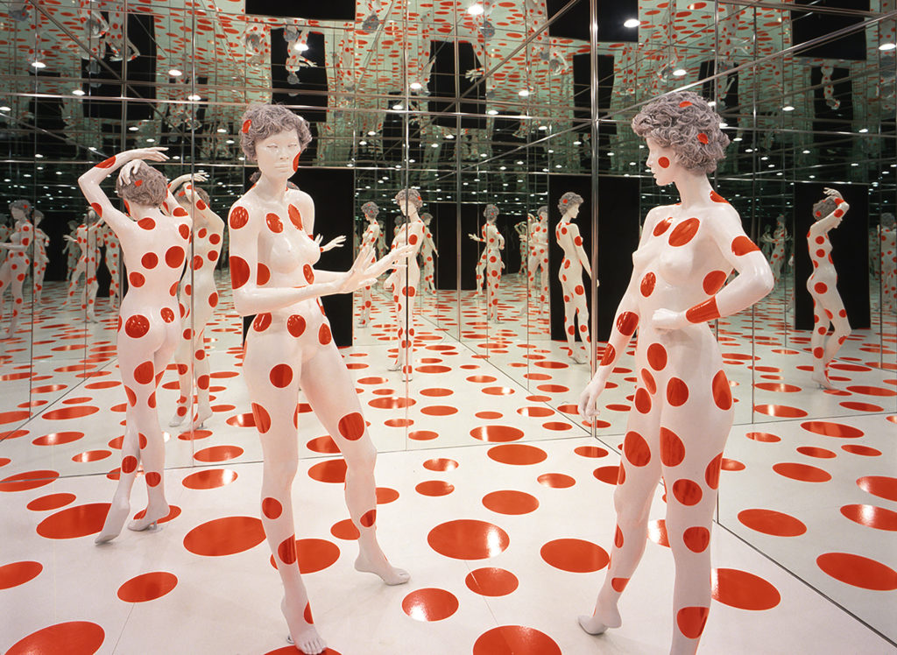
“Yayoi Kusama, the Japanese master painter, sculptor, performance, and installation artist, began her artistic career in the 1950’s….Kusama has lived by her own choice in a psychiatric hospital, maintaining an off-site studio with a staff of assistants. Her struggle with mental illness and “normalcy” is channeled into her work, which is all-consuming.…All of her work has come from a waking vision in which she sat at a table covered with a floral tablecloth, in a room covered with floral wallpaper, and saw that her hands, too, were covered with flowers. Her work explores the obliteration of the self, as the viewer becomes part of the work, reflected in mirrors, obstructed by organic forms, almost as if being sucked into the walls.”

Meow Wolf- Santa Fe (2016-current)
“House of Eternal Return”

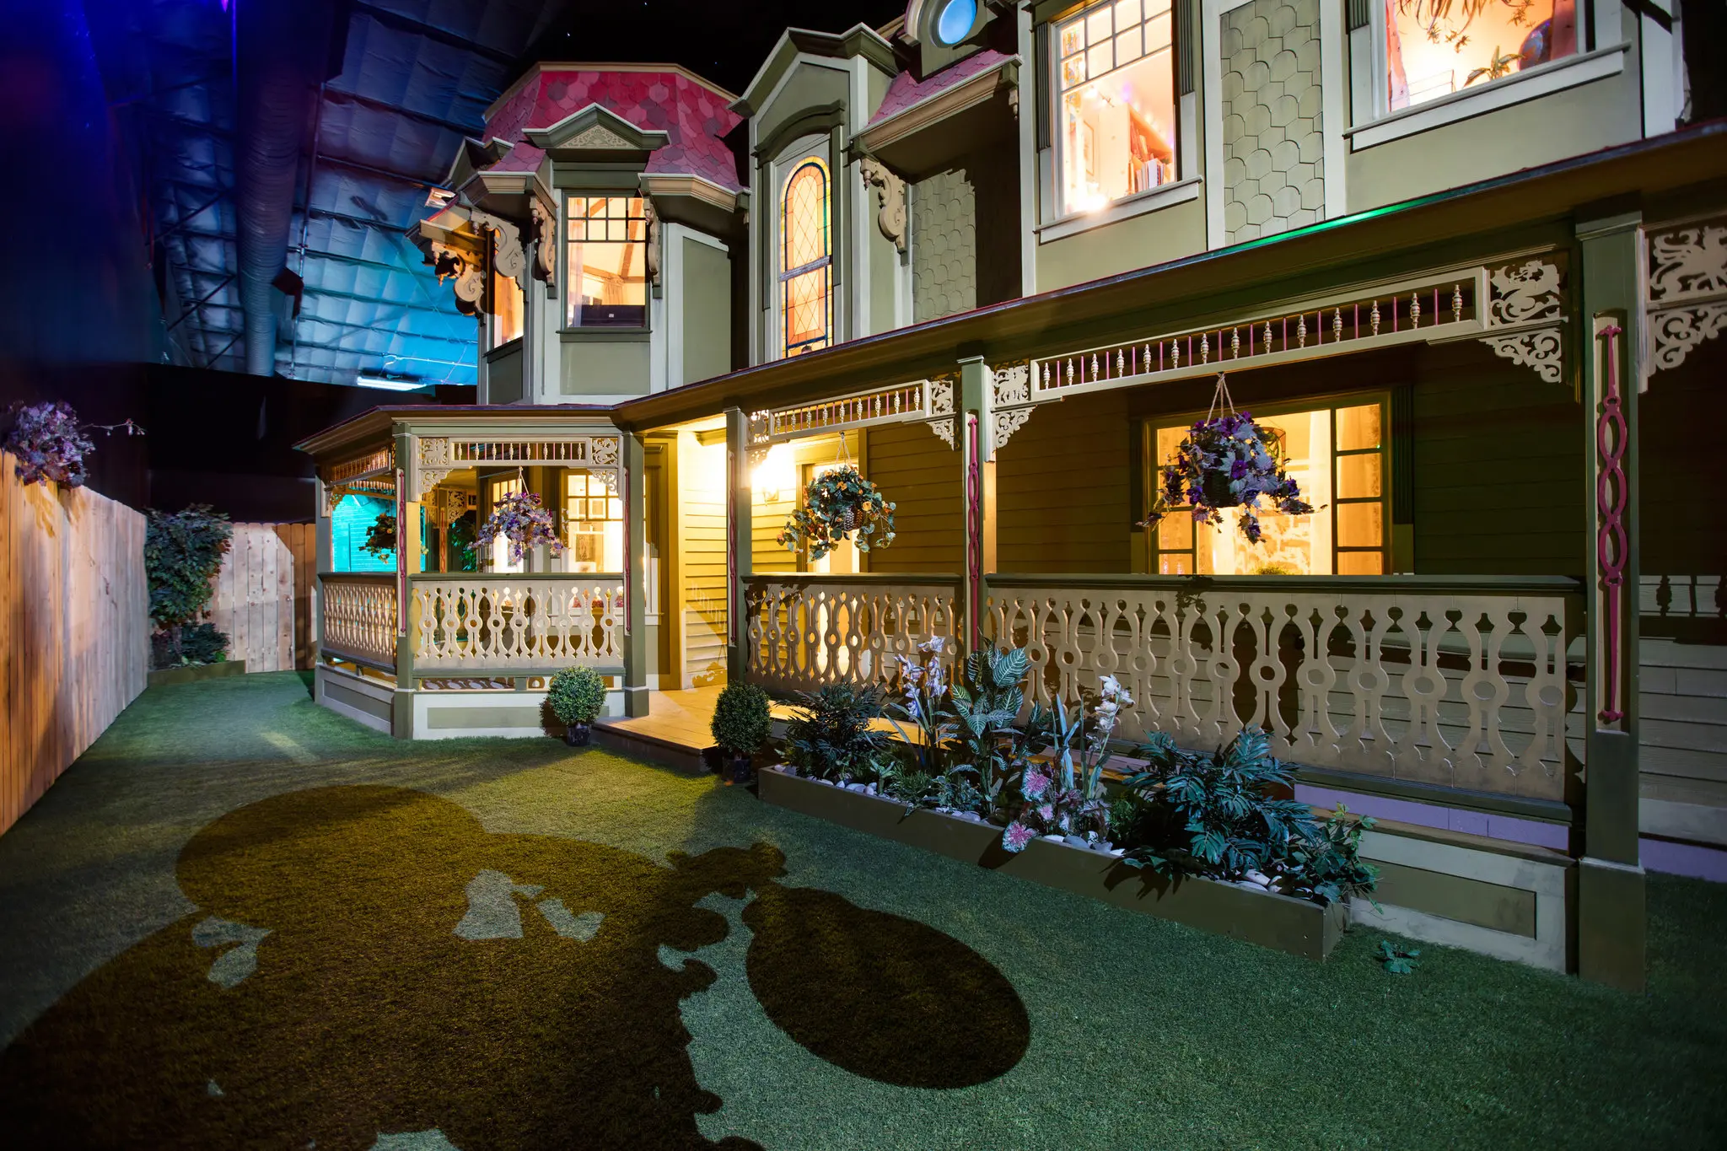
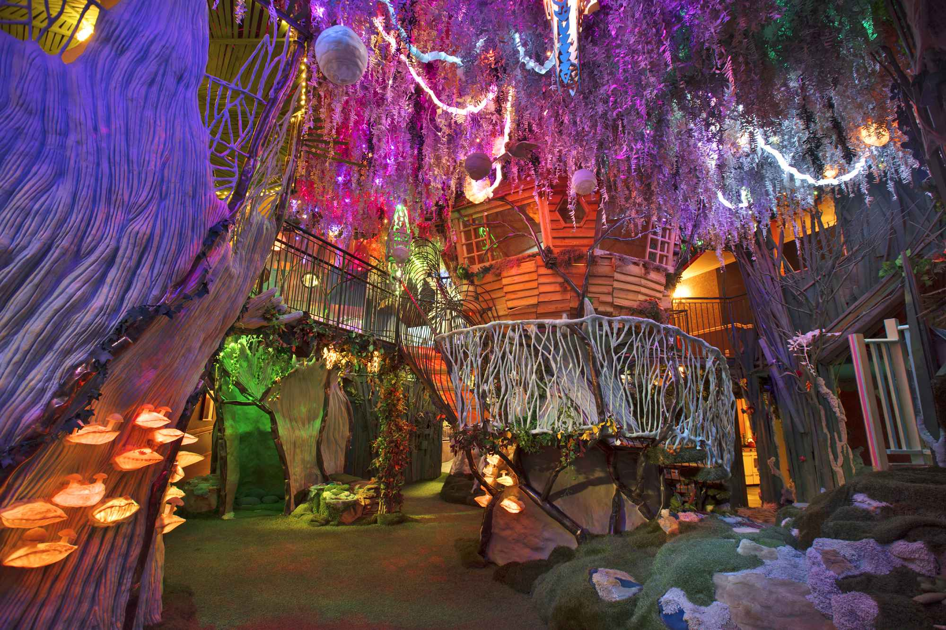
video
“Meow Wolf's House of Eternal Return is a mind-bending, explorable art experience for people of all ages in Santa Fe, New Mexico. Featuring over 70 rooms of immersive art, House of Eternal Return takes participants on a macrocosmic adventure of seemingly endless possibilities.”

V. PREREQUISITES:

Students should have an introductory understanding of installation art from previous weeks to build off of when exploring experiential art. Students also should have an understanding of how this lesson fits into our larger unit theme of viewer-artwork interaction. As far as skills go, students should be familiar with textiles, sewing, paper cutting and painting from the work we have done in past weeks.

VI. INTERDISCIPLINARY CONNECTIONS:

In this lesson students will build their skills in collaborative making, teamwork, and group problem solving. Students will brainstorm a vision for their experiential installation, and then work together to execute it. Sculpture is akin to freestyle engineering, so students will have to think through construction logistics and how to securely attach their individual work to the armature.

VII. MATERIALS NEEDED FOR LESSON
Sculpture armature:
- Large Black umbrella
Materials:
- fabric squares
- felt
- sewing needles
- Yarn
- Embroidery floss
- Fabric glue
- Scissors
- Large while paper
- Acrylic paint
- Drawing materials
- Paint brushes
- Mirrors
- Assorted lights
- Stapler
VIII. SAFETY HAZARDS:
Students will be reminded on how to use sewing needles, Fabric glue will also be available as an alternative to sewing. Students will be supervised when attaching electrical elements like lights to the umbrella armature. Students will be reminded to be cautious when handling sharp materials like mirrors and staplers.
IX. TEACHER ACTIONS / EXPECTED LEARNER ACTIONS
Time | Teacher Actions | Expected Learner Actions
9:00-9:10  10 min | -Welcome students to class and prompt them to work on the sketchbooks activity on the board. | -Arrive to class on time and check in  -Work in their sketchbooks.

9:10- 9:25  15min | - Watch the instructor show students the intro presentation. ‘  -gauge student knowledge by asking questions  -explain what experiential art is and how it differs from set building or interior design.  - show Meow Wolf video | -listening to presentation and asking questions.

9:25-9:30  5 min | -Assist in prompting discussion on brainstorming ideas for the group sculpture. Write down students' ideas. | -respectfully participating in a group brainstorm.
9:30-10:45  75 min | -walk around the classroom and supervise students while they work.  -answer questions and help students problem solve. | -work on project  -check in and collaborate with peers  -ask questions
10:45-11:00  15 min | -prompt students to share what they are working on and their idea for moving forward.  -clean up classroom with students  -give overview of what to expect next week | -share project with instructors and peers  -help clean up  -sign out of class

X. ENDING THE LESSON

X-A. Closure of Lesson:
I’m not counting on students completely finishing this week, so at the end of class we will have a check in. I will prompt a group discussion where students share their progress on part of the installations as well as their vision for their finished work. Bridget, Sage, and I will also be checking in with students throughout the work time to make sure they are on track. After the discussion students will help clean up materials.

X-B. Transition to Next Lesson:
I will be teaching the next lesson. I am planning on this project taking 2 weeks given it’s scale. Similar to how we did the silhouette lesson, we will have a wrap up day next week for this project as well as a mini lesson for students if they finish early. The mini lesson will be a drawing/painting prompt covering the use of “gaze” in art and how it can “break the fourth wall” of perspective so to speak.
XI. REFERENCES TO MATERIALS CONSULTED

https://www.artsy.net/artwork/yayoi-kusama-repetitive-vision-1
https://mattress.org/upcoming-artists/
meow wolf
https://meowwolf.com/explore/origin-story
https://www.artfervour.com/post/experiential-art-and-its-newfound-audience-on-social-media#:~:text=Experiential%20or%20immersive%20art%20is,require%20participation%20from%20the%20viewer.

XII. THE CLASSROOM AS A THIRD TEACHER

The classroom will be set up buffet style with materials lining the side tables. All materials for student use will be visible and easily accessible. One table pod will be clear for students to spread out and work on their projects. The other will be set up with sketchbooks and drawing materials like in past weeks, this is also where we will view the presentation and brainstorm ideas at the beginning of class. The front table will have the umbrella on it for students to reference and practice attaching their work to. This classroom set up will hopefully foster a studio environment where students have space and materials to pursue their individual project ideas, but can still work together in a collaborative space.

LESSON PLAN FORMAT
SAS Fall 2022
Lead Teacher: Katy Ulmer
Unit Title: Maker vs. Viewer
Lesson Title: Immersive Sculpture, Continued
Grade Level: 9-12
Number of Students: 5

I. UNIT OVERVIEW (RATIONALE)

Art is made to be experienced. One of the main thoughts of an artist while they are making should be “how is the viewer going to interact with the piece?”. We hope to convey the importance of both the maker and the viewer over this 8 week course and have the students understand the power of sharing their own experiences with the viewers of their work.
II-A. LESSON OVERVIEW (RATIONALE)

In this lesson students will continue their progress on the umbrella installation. Students will be considering their art an experience as they make visual and thematic decisions. This project will draw inspiration from examples of experiential art such as the full room installations of Meow Wolf and the Mattress Factory. By the end of class students should have collaborated to make a finished installation that considers narrative, composition, construction logistics, and atmosphere to create a cohesive visual and spatial experience for the viewer.

II-B. ESSENTIAL QUESTIONS:

-What do you think the difference is between experiential art installations and regular interior design?
-What elements contribute to the atmosphere of a space? Consider things like lighting, color, textures.
-What benefits are there to working collaboratively with other artists when creating a larger piece of work?

III-A. LEARNER OBJECTIVES/OUTCOMES
- Students will bring together skills from past weeks like sewing, embroidery, paper cutting, and drawing to create an element for the group sculpture.
- Students will work collaboratively to come up with a concept for their sculpture.
- Students create an element to add to the umbrella armature that contributes to their group vision for an experiential piece.
III-B. NATIONAL ART STANDARDS

VA:Cr1.1.Ia
Use multiple approaches to begin creative endeavors.
VA:Cr1.2.IIa
Choose from a range of materials and methods of traditional and contemporary artistic
practices to plan works of art and design.
VA:Cr2.3.Ia
Collaboratively develop a proposal for an installation, artwork, or space design that transforms the perception and experience of a particular place.

III-C. PENNSYLVANIA DEPARTMENT OF EDUCATION STANDARDS

9.4.12.B.
Describe and analyze the effects that works in the arts have on groups, individuals and the culture

IV. ART / ARTIST(S) OF RELEVANCE:

Yayoi Kusama
“Repetitive Vision”, 1969

“Yayoi Kusama, the Japanese master painter, sculptor, performance, and installation artist, began her artistic career in the 1950’s….Kusama has lived by her own choice in a psychiatric hospital, maintaining an off-site studio with a staff of assistants. Her struggle with mental illness and “normalcy” is channeled into her work, which is all-consuming.…All of her work has come from a waking vision in which she sat at a table covered with a floral tablecloth, in a room covered with floral wallpaper, and saw that her hands, too, were covered with flowers. Her work explores the obliteration of the self, as the viewer becomes part of the work, reflected in mirrors, obstructed by organic forms, almost as if being sucked into the walls.”

Meow Wolf- Santa Fe (2016-current)
“House of Eternal Return”

video
“Meow Wolf's House of Eternal Return is a mind-bending, explorable art experience for people of all ages in Santa Fe, New Mexico. Featuring over 70 rooms of immersive art, House of Eternal Return takes participants on a macrocosmic adventure of seemingly endless possibilities.”

V. PREREQUISITES:

Students should have an introductory understanding of installation art, textile work, and sculpture from last class and previous weeks to build off of in their continued exploration of experiential art. Students also should have an understanding of how this lesson fits into our larger unit theme of viewer-artwork interaction. As far as skills go, students should be familiar with textiles, sewing, paper cutting, etc, and have already started work on components for the umbrella sculpture.

VI. INTERDISCIPLINARY CONNECTIONS:

In this lesson students will continue to build their skills in collaborative art making, teamwork, and group problem solving. Students will work together to coordinate components for their experiential installation. Sculpture is akin to freestyle engineering, so students will have to think through construction logistics and how to securely attach their individual work to the armature.

VII. MATERIALS NEEDED FOR LESSON
Sculpture armature:
- Large Black umbrella
Materials:
- Fabric squares
- Felt
- Sewing needles
- Yarn
- Embroidery floss
- Fabric glue
- Scissors
- Large while paper
- Acrylic paint
- Drawing materials
- Paint brushes
- Mirrors
- Assorted lights
- Stapler
VIII. SAFETY HAZARDS:
Students will be reminded on how to use sewing needles– fabric glue will also be available as an alternative to sewing. Students will be supervised when attaching electrical elements like lights to the umbrella armature. Students will be reminded to be cautious when handling sharp materials like mirrors and staplers.
IX. TEACHER ACTIONS / EXPECTED LEARNER ACTIONS
Time | Teacher Actions | Expected Learner Actions
9:00-9:15  15 min | Welcome students to class and prompt them to jump back into working on their sculpture components from last class. | - Arrive to class on time and check in.  - Gather materials and begin work on installation components.

9:15- 9:20 min | Give refresher on project info from last class, and introduce timeline for lesson 7.  - Let students know that they have until 10:30 to complete sculpture components, then we will focus on attaching them to the umbrella. | Listening and voicing any questions.

9:20-9:30  5 min | Student work time  - Check in with each student to touch base on what their vision is for their project and see if they need any help brainstorming or thinking through construction problems.  - See if students want help with more tedious tasks like stringing beads or sewing individual pieces to the umbrella armature. | - Working on projects.  - Collaborating and sharing ideas with teachers and peers.  - Voicing any questions
10:30-10:55 | Prompt students to wrap up work and transition to installing components on the umbrella. | - Help install work  - Problem solve how to attach and arrange group work

X. ENDING THE LESSON

X-A. Closure of Lesson:

Near the end of class I will give periodic reminders to wrap up work so it can be installed on the umbrella. The last 20 or so minutes will be dedicated to bringing all the sculpture components together to create their collaborative installation. After the project wrap-up, students will help clean up materials.

X-B. Transition to Next Lesson:

During wrap-up time in the last 10 minutes of class, we will give a brief overview of what the students should expect next week. We will not be starting another project, instead we will be using week 8 as a wrap up for the unit. lesson 8 is another team teaching day. Our plan is to take the students to Zollar gallery for a gallery walk, this will help them become familiar with the space where the exhibition will be. When we return to the classroom the students will work on planning out how they want their work installed, and create any extra display details like signs.
XI. REFERENCES TO MATERIALS CONSULTED

https://www.artsy.net/artwork/yayoi-kusama-repetitive-vision-1
https://mattress.org/upcoming-artists/
meow wolf
https://meowwolf.com/explore/origin-story
https://www.artfervour.com/post/experiential-art-and-its-newfound-audience-on-social-media#:~:text=Experiential%20or%20immersive%20art%20is,require%20participation%20from%20the%20viewer.
XII. THE CLASSROOM AS A THIRD TEACHER

The classroom will be set up buffet style with materials lining the side tables. All materials for student use will be visible and easily accessible. One table pod will be clear for students to spread out and work on their projects. The other will be set up with sketchbooks and drawing materials like in past weeks. The front table will have the umbrella on it for students to reference and practice attaching their work to. This classroom set up will hopefully foster a studio environment where students have space and materials to pursue their individual project ideas, but can still work together in a collaborative space.

LESSON PLAN FORMAT
SAS Fall 2022
Lead Teacher: Sage Kugler, Bridget Toren, Katy Ulmer
Unit Title: Maker vs. Viewer
Lesson Title: Putting it All Together: Galleries, Titles, Bios, Oh My!
Grade Level: 9-12
Number of Students: 5

I. UNIT OVERVIEW (RATIONALE)
Art is made to be experienced. One of the main thoughts of an artist while they are making should be “how is the viewer going to interact with the piece?”. We hope to convey the importance of both the maker and the viewer over this 8 week course and have the students understand the power of sharing their own experiences with the viewers of their work.
II-A. LESSON OVERVIEW (RATIONALE)
In this lesson students will be wrapping up their projects from the past 7 weeks and thinking about how the works will be displayed and installed in our final show in Zoller gallery. They will be planning out the scene for their silhouette pieces, naming the three collaborative projects, and making name cards for them. We will be giving a brief presentation on the importance of a name in a piece of artwork. This lesson will be the time when we can really think about how the viewers are interacting with our pieces in the gallery space and tying together our big idea of maker vs viewer.

II-B. ESSENTIAL QUESTIONS:
How might the gallery space influence the artwork’s display?
How might a title aid in the viewer's understanding?
How does the positioning of artworks in a gallery setting help or hinder the pieces?
What are some thematic influences within artworks that influence the viewer’s experience?

III-A. LEARNER OBJECTIVES/OUTCOMES
Students will assist in organizing their pieces in the gallery and planning the positioning of their work.
Students will brainstorm names for their collaborative pieces and make title cards for them.
Students will write a brief artist bio about themselves and the work they did this semester.

III-B. NATIONAL ART STANDARDS
VA:Pr5.1.Ia: Analyze and evaluate the reasons and ways an exhibition is presented.
VA:Re.7.2.IIa: Evaluate the effectiveness of an image or images to influence ideas, feelings, and behaviors of specific audiences.
VA:Re.7.1.Ia: Hypothesize ways in which art influences perception and understanding of human experiences.
III-C. PENNSYLVANIA DEPARTMENT OF EDUCATION STANDARDS
9.4.12.B: Describe and analyze the effects that works in the arts have on groups, individuals and the culture

IV. ART / ARTIST(S) OF RELEVANCE:

Example of silhouette project installation:

Kara Walker
New York-based artist Kara Walker is best known for her candid investigation of race, gender, sexuality, and violence through silhouetted figures that have appeared in numerous exhibitions worldwide.

Example of experiential art:

Meow Wolf- Santa Fe (2016-current)
“House of Eternal Return”

“Meow Wolf's House of Eternal Return is a mind-bending, explorable art experience for people of all ages in Santa Fe, New Mexico. Featuring over 70 rooms of immersive art, House of Eternal Return takes participants on a macrocosmic adventure of seemingly endless possibilities.”

Example of how the title affects the impact of the work:

Marcel Duchamp “The Bride Stripped Bare by Her Bachelors, Even (The Large Glass)”, 1915-23, oil, varnish, lead foil, lead wire, dust, two glass panels.
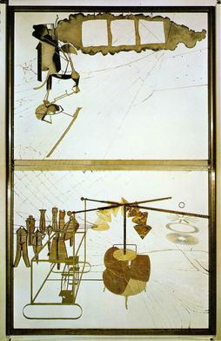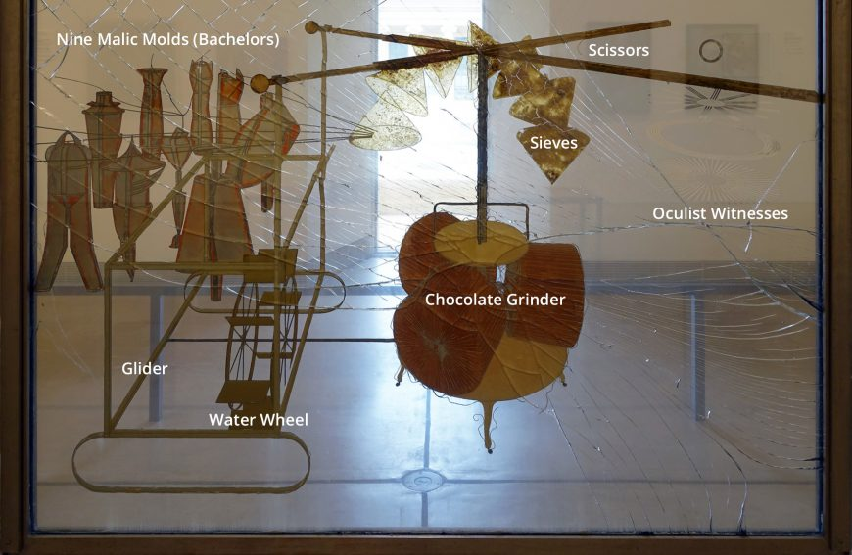

V. PREREQUISITES:
Students should have an understanding of the projects we have completed previously in the semester. Students should be able to collaborate with peers.

VI. INTERDISCIPLINARY CONNECTIONS:
This lesson can be connected to language arts because the students will be coming up with creative titles for their collaborative pieces. The students will be thinking about how to title the pieces in a way that is interesting and can aid the viewer in better understanding the piece.

VII. MATERIALS NEEDED FOR LESSON

- tape
- silhouette pieces
- cardstock
- drawing materials (markers, colored pencils, etc. )
- scissors
- polaroid camera
- glue
- Artist bio card template

VIII. SAFETY HAZARDS:
Students need to be careful when crossing the street on the walk over to Zoller Gallery. Students will be escorted by teachers and classroom volunteers when doing so.

IX. TEACHER ACTIONS / EXPECTED LEARNER ACTIONS

Time | Teacher Actions | Expected Learner Actions
9:00 - 9:15  15 mins | Welcome students to class and have them begin working in their sketchbooks as other students arrive. | - Arrive to class on time and check in.  - Gather materials and begin working in sketchbook
9:15 - 9:30  15 mins | Walk students over to Zoller Gallery with students. Have one instructor, and one volunteer stay behind to escort late students to the gallery.  Have discussion with students about gallery layout and various ways to display artwork. | - Students will go to the gallery and see the space  - Engage in discussion about layout of space
9:30 - 9:50  20 mins | Help students in laying out their silhouette pieces from week 3 on the floor of the classroom and planning out the scene they want to create. Helping them make sure the display is to scale for the space in the gallery. | - laying out silhouettes  - planning scene for the silhouettes  - thinking about how they will be displayed on the wall in Zoller that they just saw  - asking questions as needed
9:50 - 10:10  20 mins | We will present to the student about creating title names and creating mini artist statements and how those descriptions impact the viewer’s perception of art. | - Listen and engage with presentation  - ask questions when needed
10:10- 10:20  10 mins | Helping students brainstorm their titles for the collaborative pieces they have made. They will be making titles for their silhouette scene, class quilt tact-tiles, and umbrella installation. Helping answer questions if needed. | - brainstorming ideas for titles for collaborative pieces  - collaborating with peers on titles  - asking questions when needed
10:20 - 10:45  25 mins | Monitoring students as they are working on their title cards. Helping answer questions as needed. | - working together with peers to make title cards for the collaborative pieces that they just came up with titles for  - asking questions when needed
10:45 - 10:55  10 mins | Handing out artist bio templates to students, taking photos of each student, and answering questions that may come up. | - filling out and decorating artist bio card  - getting photo taken for artist bio card  - asking questions as needed
10:55 - 11:00  5 mins | Assist students in cleaning up and organizing their title cards, installation work, and bios. | - Students will gather their gallery items and put them away

X. ENDING THE LESSON

X-A. Closure of Lesson:
In their artist bio, students will be reflecting on the semester as a whole and the projects they have completed. Also, this entire lesson is a closure in a way since we are wrapping up our ideas of maker vs viewer and thinking out the viewers that will be in the gallery seeing the work.
XI. REFERENCES TO MATERIALS CONSULTED
https://smarthistory.org/duchamp-largeglass/
meow wolf, house of eternal return
http://www.karawalkerstudio.com/

XII. THE CLASSROOM AS A THIRD TEACHER

We will be using the Zollar gallery as a third teacher in this class. In addition to explaining the importance of the composition of their gallery display, students will be able to physically visit the gallery where their work will be displayed. Another show will be in the gallery at the time, this will give them first person insight into how other artists choose to use the space to display their work. Back in the arts cottage classroom we will have the students use the open floor space to arrange the silhouette project how they want it displayed in the gallery.

